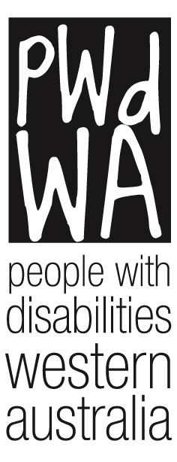

People with disabilities WA

Annual Report 2019-2020

Acronyms used in this report

AAT Administrative Appeals Tribunal
AFDO Australian Federation of Disability Organisations
AT Assistive Technology
AWA Advocacy WA
CBT Cognitive Behaviour Therapy
CaLD Culturally and Linguistically Diverse
COVID-19 Corona Virus 2019
DFO Diversity Field Officer
DoC Department of Communities
DRC Disability Royal Commission into Violence, Abuse, Neglect and Exploitation of People with Disability
DSP Disability Support Pension
DSS Department of Social Services
ILC Information, Linkages, and Capacity Building
LAC Local Area Coordinatior
NBN National Broadband Network
NDAP National Disability Advocacy Program
NDS National Disability Services
NDIA National Disability Insurance Agency
NDIS National Disability Insurance Scheme
PWdWA People With disabilities (WA) Inc.
SCHADS Social, Community, Home Care and Disability Services Industry Award 2010
SDA Specialist Disability Accommodation
SSCLS Sussex St Community Law Service
WA Western Australia

FromChair

Contents

About Our Organisation
From Our Chair
Committee of Management
From Our Executive Director
PWdWA Staff
PWdWA Members
Key Achievements
Individual Advocacy
Trends and Case Studies
Systemic Advocacy
Projects
Key Relationships
Treasurers Report
Financial Statements

About Our
Organisation

Our Vision
People with disability are equal and valued citizens.

Our Mission
Advocating for the rights, and empowering people with disability in WA.

We value
- Human rights
- The unique experiences of people with disability
- Self-empowerment- supporting people to take control of their own lives

Guiding principles

We will:
- Be passionate, innovative and fearless in defending and promoting the rights and interests of people with disability.
- Be available to people to listen and respond to their needs.
- Adapt our services to suit people’s individual needs and circumstances.
- Be well researched and think carefully about our advice and actions.
- Work and maintain relationships with other organisations who have similar aims and objectives.
- Be open and honest about everything we do.
- Use resources in the most efficient way possible.
- Involve people with disability in everything we do.
- Value our staff, committee and volunteers.

From Our
Chair
Welcome to our Annual Report for 2020. At the time of going to press, it is never certain when we will be able to see our community face to face, due to the looming presence of COVID-19.The impact of COVID-19 on our community has shaped 2020 and the lives of many for years to come. PWdWA have been at the forefront in WA on engagement around how these issues are affecting people with disabilities.
In March, our Advocates and office team moved offsite to continue their work at home. New ways of working were found, and resources strengthened. It is testament to the skills of our team that we continued to provide quality services. We continued our ongoing core work of providing high quality individual advocacy to the WA community, alongside our consortium partners, Sussex Street Community Law Service and Advocacy WA.
We continue to strive to achieve our strategic goal of wider recognition as the peak disability rights and advocacy organisation in WA. Our membership increased by 11% in the past year. The committee benefited from the excellent work of our new community engagement role, allowing for our regular (COVID-19 permitting) committee ‘Meet and Greets’, newsletters and increased social media reach.
With planning well underway, we are thrilled to be holding our first PWdWA Self Advocacy Conference, run for and by people with disabilities, later in the 2020 year. I would like to thank Samantha Jenkinson for her oversight of the conference committee, and our Committee of Management members, Adam Hewber and Simon Chong for their time on the conference. I would also like to acknowledge the support of Katrina Bercovf rom Evolve Events and Training in coordinating the event with the support of other conference committee members, Jackie Green, Jarmin Dix, Kirsten Whent and Jethro Hepton.
PWdWA have remained active in our systemic project work, vocal in the media and produced submissions on a range of important issues, as listed in the Executive Director’s report.
We will bid farewell to our Executive Director, Samantha Jenkinson, who worked tirelessly for PWdWA in her five and a half years. She built on the work of her predecessors to implement many systemic advocacy projects and submissions; implement a strong structure for our individual advocacy and was skilled at bringing in funding in an environment of scarcity. She worked well with her teams and with the committee, and we are sad to see her go, while also pleased for her new position allowing her to broaden her reach.
The Committee worked hard to recruit a new Executive Director, and thanks Mallika McCleod for stepping in as an independent panel assessor. We welcome Brendan Cullinan, who has a strong track record in leadership and strategic accomplishments in executive roles for not-for-profit organisations. He has shown a commitment to inclusion and upholding the rights of people with disabilities in his previous roles. We continue to have a highly engaged Committee of Management maintaining responsible and strong governance, with a focus this financial year on risk and policy. We conducted a risk workshop and strengthened our risk management processes, as well as working with the Executive on updating our governance policies.
Since the last AGM, we have said goodbye and thank you to Karen Andersson, who brought skills to our committee in her role as Treasurer; and Matthew Lee, who we hope can return to us when he is able. We have been able to second new committee members Lara Moore and Kat Johns. We are appreciative to our committed, approachable, and diverse group of volunteers living with disability on our Committee - thank you Janine, Adam, Simon, Erin, Bob, Tara, Kat, Lara, and Erika, our secretariat. I would also like to acknowledge the work and commitment of our staff and note it is incredible how the diversity of our committee and our staff enhances the strength of our organisation.
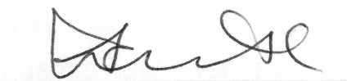
Lisa Burnette
President

Our Committee of Management
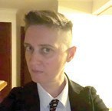
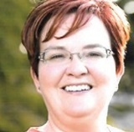
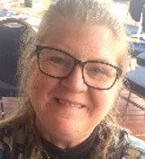
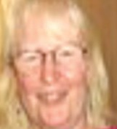
Lisa Burnette – Chair

Janine Neu – Deputy Chair

Adam Hewber – Treasurer from 23/03/2020

Simon Chong – Committee Member

Kat Johns – Committee Member

Bob Johnson – Committee Member

Tara Le Flohic – Committee Member

Matthew Lee – Committee Member

Erin Marshall – Committee Member

Karen Andersson – Treasurer (Resigned 23/03/2020)

Erika Webb – Secretariat

From Our
Executive Director

This is my fifth and final report for PWdWA. It has been a privilege to lead such a unique and necessary organisation that is the peak consumer voice for people with all disabilities in WA. The 2019-2020 year has seen continued support with non-recurrent funding from the State government, and yet a continued uncertainty for future funding that meets the demand for individual advocacy from both state and federal governments.
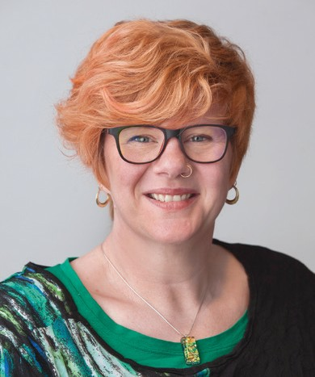
Our individual advocacy continues to be in high demand with over 1000 people contacting us throughout the year. Through our Consortium for Individual Advocacy with Sussex St Community Law Service (SSCLS) and Advocacy WA (AWA) we received non-recurrent funding to assist with our waiting list, and funds to reach out with individual advocacy into regional areas. The number of people needing advocacy on our waiting list, which we have needed to implement for a second full year, has not changed, however through this project funding our quality of intake has improved. The majority of people calling PWdWA were supported with detailed information or one-off meetings to provide advice and strategies for people to self-advocate.
Samantha Jenkinson
ch we
Assisting people with National Disability Insurance Scheme (NDIS) issues continues to be the highest area of need. Advocacy is providing positive outcomes with the majority of those we support through appeals being successful in getting what they need. Our concern is that people who need advocacy in other areas of life such as housing, income support, or dealing with justice and child protection systems are being delayed while we have such a strong focus on NDIS.
The start of the Disability Royal Commission into Violence, Abuse, Neglect and Exploitation of People with Disability (DRC) was great to see, particularly after all the work that many in the sector including PWdWA have done to raise the reality of abuse, neglect, and systemic ableism and exploitation. We worked with the other funded advocates in WA to develop the ‘Share Your Story, Shape Our Future’ campaign so the experiences of West Australians with disability are heard. It didn’t get the start we hoped due to COVID-19, but we have seen an increase in people coming to us to get assistance to put in submissions to the DRC.
The NDIS Transition and Interface Systemic Advocacy project ended on June 30 2020 with a comprehensive report of people’s experience of the NDIS in WA. The project fostered a continuous improvement framework with the NDIA and Local Area Coordinator (LAC) partners actively participating with a diverse group of people with disability and families to hear issues and discuss solutions first hand.
At the systemic level, we have been involved in meetings, advisory, and reference groups on topics like housing, self- management, and NDIS Industry issues. Our report highlights the areas where we prioritised the systemic advocacy work we do and some of our achievements. The trends and case studies from our consortium and individual advocacy work also feed into our systemic advocacy. The NDIS and transition to NDIS continues to be over half of our systemic advocacy, on top of our specific NDIS systemic project. Housing and of course the impact of COVID-19 were the other two areas of major focus.
PWdWA is often asked to present at events, provided advice, take part in advisory groups, and put in submissions to inquiries. All the submissions we make are publicly available on our website. This year we provided submissions on the impact of COVID-19, NDIS planning and implementation, and the review of the Residential Tenancy Act. I also had the privilege of providing input to the State Housing Strategy. Seeing the increased understanding and commitment to accessible housing shows our long term work bearing fruit.
The commitment from the State government towards using Co-design with support from PWdWA in the State Disability Strategy is also a shift in thinking with ‘nothing about us, without us’ becoming embedded in practice through the use of Co-design.
Examples of areas we have been asked to present and/or provide advice on are:
- Housing and the NDIS
- NDIS Contemporary Practice and Innovation
- NDIS Self-Management
- Disability Employment Australia Conference
- Employment and employment targets
- Co-design of services
- Restrictive Practices Authorising Framework
- Impact of Climate on Health
- Palliative Care
- 10-year State Disability Strategy
- 10-year State Housing Strategy
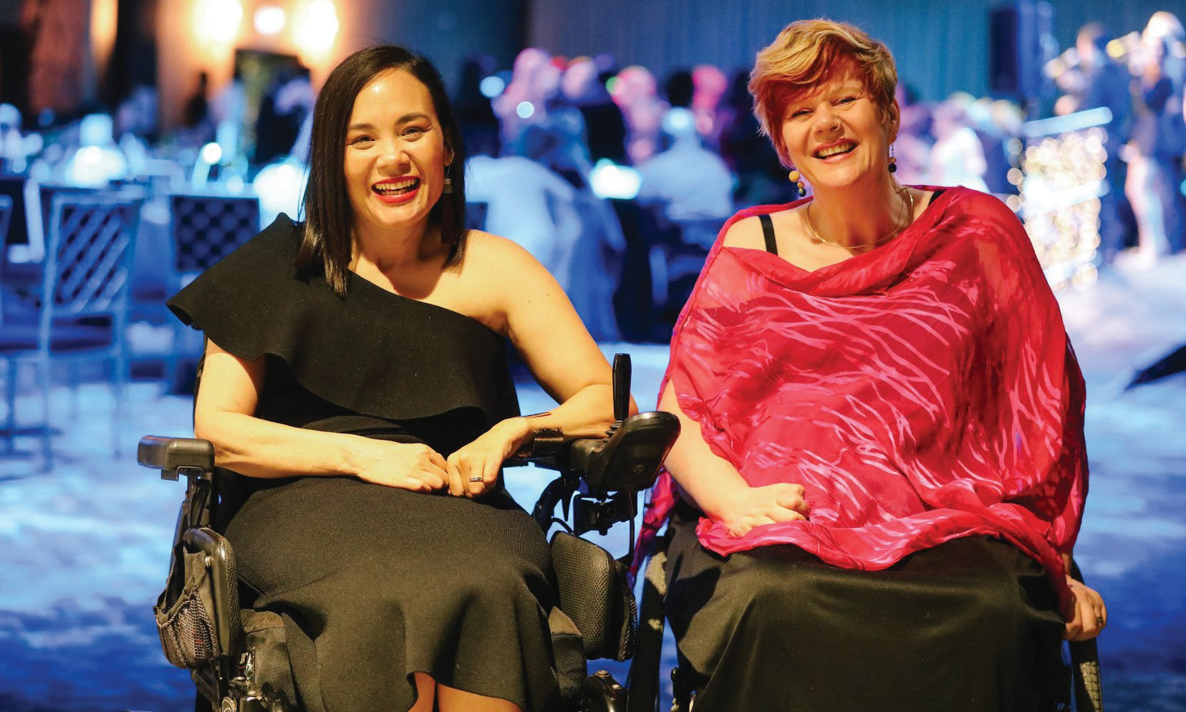
This year also saw PWdWA gain funding for a three-year project through the National Disability Insurance Agency Information, Linkages and Capacity Building (NDIA ILC) grant to build our organisational capacity as well as self-advocacy and peer support particularly in the regions. This work will enable PWdWA to continue to build on and use the resources developed in the projects which all finished in September 2019 - Co-design; On Board with Me (Board Disability Diversity project); and Empowering Health Consumers with Disability. It is also putting into practice the member engagement strategy developed through the current NDIA ILC project. The Diversity Field Officer (DFO) project has been the other ILC project to continue with national funding and focus on increasing the capacity of businesses to employ people with disability. Some great examples and stories are highlighted in the project reports.
9
Jos Fransiscus and Samantha Jenkinson at 'The Lives We Lead' Gala Ball
It was an absolute pleasure in December 2019 to be asked to co-host the ‘The Lives We Lead’ Gala Ball with Jos Fransiscus. The digital stories are still going strong and show how to share stories of people which are a celebration of who they are, and not a focus on disability pity or misplaced inspiration.
Thank you to my colleagues in the Disability Coalition for our great collaborative work on systemic advocacy projects, and to Tania McInness at AWA and Jane Timmerman is from SSCLS for continuing to work with me in our successful consortium partnership.
Thank you to all the staff, students, interns, and volunteers at PWdWA. The supportive and passionate culture of the team makes it a great place to work. The ongoing high demand from people dealing with complex situations and systems puts a lot of stress on the staff, and they work hard to get the best outcomes they can for people. Our administration and project staff at PWdWA are no less passionate and dedicated to delivering our mission of advocating for the rights and empowering people with disability. I particularly thank Brianna Lee, Lisa Hook and Renata Krollig who have provided support to the whole team and to me in my role as Executive Director.
The Committee of Management has been actively involved in engaging with members, promoting the organisation and value of lived experience of disability in governance. Special thanks to Lisa Burnette, our Chair, who has been an active and committed leader of PWdWA.
I wish the incoming Executive Director, Brendan Cullinan, all the best and I am sure that like myself he will find the support and passion of this unique organisation stays with him.
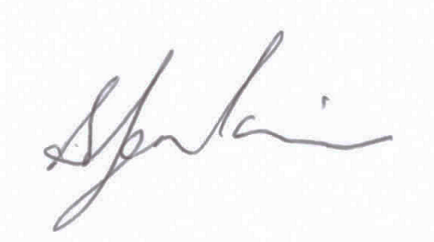
Samantha Jenkinson
Executive Director

PWdWA Staff

Samantha Jenkinson – Executive Director
Brianna Lee – Individual Advocacy Service Manager (Maternity Leave 6 months)
Lisa Hook – Individual Advocate and Individual Advocacy Service Manager
Michele Frost – Individual Advocate
Rachael Cox – Individual Advocate NDIS Appeals
Elisha Johnson – Individual Advocate
Glenda Bye – Individual Advocate
Chris Chambers – Individual Advocate
Kerry Kessner – Individual Advocate
James Cresswell – Individual Advocate
Catherine Everett – Individual Advocate (casual)
Oliver Offer – Disability Royal Commission Advocate
Mark Hutson – Regional Outreach Advocate
Jessica Eastaugh – Diversity Field Officer
Dr Amber Arazi– Member Engagement Project Officer
Tahnee Gilmour – Self Advocacy and Peer Support Project Officer
Vanessa Jessett – Organisation Development and Communications Officer
Sonya Gozuacik – Administration Officer (Maternity Leave)
Renata Krollig – Administration Officer
Anne Livingston – NDIS Systemic Advocacy Project Officer
Talitha Mberi – Project Assistant
Suresh Rajan – State Disability Plan Engagement (contract ended December 2019)
Martin Duff – Empowering Health Project Officer (contract ended October 2019)
Tracy Destree – On Board Project Officer (Contract ended October 2019)
Aimee Silverman – Individual Advocate (resigned June 2020)

PWdWA Members
PWdWA Members
- Full Members - 373
- Associate Members - 193
- Organisational Members - 23
- Life Member - 9
PWdWA values the feedback and information our members provide us. They are an integral part of our advocacy work. Members are regularly updated about our activities throughout the year and invited to participate and give feedback. People with disability are invited to become full members. Families and friends are invited to become associate members and we also offer organisational memberships.

Key Achievements
- We worked with the WA state government to help codesign the new state disability strategy.
- Australian government we provided individual advocacy support for people to make submissions to the Royal Commission into violence abuse neglect and exploitation of people with disability.
- NDIS, A co-design group partnered with the NDIA an NDIS LLC partners to make recommendations around individual and systemic barriers arising from NDIS transition in WA.
- We commenced working with the small and medium sized businesses to provide education and mentoring to help them feel more confident about disability inclusion in their workplace.
- 1011, the number of people with disabilities supported by our individual advocates.
- We delivered self-advocacy your rights your voice your choice courses.
- We continued to deliver quality advocacy support remotely during the COVID-19 lockdown.
- We continued to work collaboratively with the vector to provide strong organisational governance.
- We secured funding from the day OC to support the implementation of the whiteness project.

Individual Advocacy
PWdWA provides independent non legal advocacy to people with a disability in WA. Advocacy is the process of standing alongside individuals to ensure that they are able to speak out, express their views and uphold their rights. Our advocacy services include providing information, making supported referrals and individual advocacy for standard and complex cases. During the 2019-2020 financial year, PWdWA Advocates have provided advocacy to 1011 people with 1985 issues, an increase of over 250 people compared to the last financial year. These numbers indicate a huge increase in advocacy provided by PWdWA. We thank our Individual Advocates for their dedication, hard work and passion. They continue to do outstanding work in the face of increasing pressures.
PWdWA is funded to provide Individual Advocacy federally by Department of Social Services (DSS) (46% of funding) and in WA by the Department of Communities (DoC) (54% of funding). PWdWA works as part of a consortium that includes Individual Disability Advocacy Service as part of Sussex St Community Law Service (SSCLS) and Advocacy WA (AWA). The DSS also provides funding for the National Disability Insurance Scheme (NDIS) Appeals Advocate and the Disability Royal Commission (DRC) Individual Advocate.
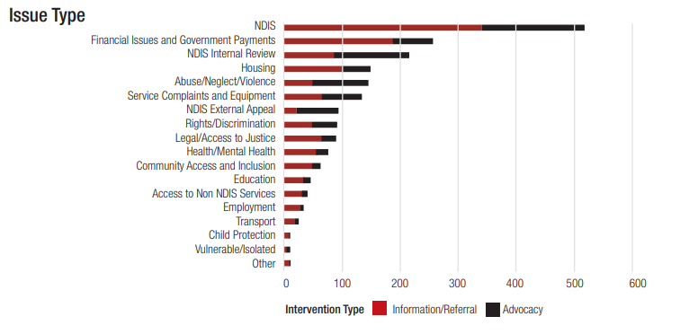
The graph above shows disability types for our clients. Physical disability, autism, neurological and Psychiatric disability were the most reported types of disability.
The graph above shows the types of issues that Advocates have worked on throughout the last financial year.
The graph demonstrates the highest advocacy provision by PWdWA Advocates during the last year has been NDIS combined with NDIS Internal Reviews and NDIS external Appeals at 863 issues. The next largest type has been financial issues and government payments at 255.Wehave seen an increase in the number of issues relating to abuse, neglect and violence compared to the last financial year (143 issues). This is due to the DRC and people contacting us about making a submission

Waitlist project
The Waitlist Project has been funded by the DoC from December 2019 to December 2020.We have been analysing all the standard, complex and informational cases that have presented to the service to see where our resources are best utilised, as well as looking at how often individuals return to our service and what they are returning for. During this year, we have noticed that NDIS related issues make up around half of our calls and that nearly two-thirds of those are related to NDIS access requests. Because of the increasing demand for advocacy our waitlist has only been open to urgent issues for most of the year and at one point we had to close our waitlist to any new issues for five weeks.

The Disability Royal Commission
PWdWA employed a DRC Individual Advocate in November 2019 to deliver outreach and assist people to engage with the Royal Commission into Violence, Abuse, Neglect and Exploitation of People with Disability. PWdWA established a working group with other advocacy organisations for support on this project.
In conjunction with the five other advocacy organisations, PWdWA coordinated a media campaign with the support from publicity company Cannings Purple. The campaign aimed to help inform the community about the DRC and provide education about the support services available. As part of this campaign, PWdWA launched a website, produced articles for the West Australian Newspaper, developed a range of digital advertisements, and developed physical materials that were distributed to existing networks. A major campaign event planned for Parliament house was cancelled due to COVID-19 restrictions, but the campaign has been widely shared online reaching several thousand people between March and up to the end of June.
In the first quarter of 2020, PWdWA started working with individuals as they decided how to engage with the DRC and if they wanted to make a submission. The established advocacy services provided by PWdWA Advocates formed an important early step in informing people about the DRC and where to find support with many initial referrals coming from internal sources. In the first six months of 2020 PWdWA assisted with six submissions to the DRC, and our Advocate is continuing to work with a full caseload of individuals.

Trends and Case Studies

NDIS
NDIS is the largest issue PWdWA has provided advocacy for this financial year. This includes internal reviews, external reviews, access requests and support implementing plans/accessing services. We particularly saw an increase in people asking for help with an internal review to access the NDIS. Generally, this means that the individual’s application for the NDIS has been rejected. PWdWA have had great success in reversing original decisions made by the NDIS. Advocates are still having issues contacting and getting information from the NDIS to pass on to individuals.

Susie’s story
Susie has neuropathic pain and has applied for access to the NDIS. Susie’s application was rejected because her disability was not considered to be a permanent disability. The doctor referenced a need for Cognitive Behaviour Therapy (CBT). Susie has had a lot of CBT in the past and sees it as being part of ongoing management rather than curative treatment. Susie went through the Internal Review process to appeal the decision and was again rejected access to the NDIS.
Susie contacted PWdWA to ask for advocacy through the Administrative Appeals Tribunal (AAT) process. The Advocate was able to assist Susie to apply for Legal Aid NDIS assistance and gather relevant information and evidence. The Advocate attended the AAT hearing with Susie. The outcome was that Susie gained access to the NDIS through the AAT Appeal process and is now able to live independently in the community.

Financial Issues and Government Payments
Support for accessing the Disability Support Pension (DSP) continued to increase over the last financial year. These financial matters make up 12.8% of the total issues. People are finding it harder to complete and gather all the correct information to prove their cases.

Jack’s story
Jack was unable to get assistance to go through the AAT Process from other agencies to gain access to the DSP. Jack was unable to get the DSP because Centrelink said his disability is not fully diagnosed, treated or stabilized despite new evidence to the contrary. The Advocate was able to help Jack to understand the process and gather all the required evidence and attended the AAT hearing. Once putting his case forward to the AAT and Centrelink lawyers, Jack was advised that he meets the eligibility criteria and was granted the DSP and back paid accordingly.

Housing
The 2019-2020 period has had the added complication of COVID-19, isolation and a change in tenancy legislation to protect people from eviction during the pandemic. The new legislation meant that no one could be evicted during the pandemic.
Unfortunately, people and housing providers were not aware of these measures and PWdWA helped several individuals who were threatened with eviction.
Sylvia’s story
Sylvia is in her forties and has a psychosocial disability. Sylvia had just left a violent relationship and was staying in community housing. The Housing service provider advised her that she was being evicted for non-payment of rent. The Advocate advised the service provider that they were unable to evict Susie as the legislation had changed during the COVID-19.Afterconversations with the individual, the Advocate discovered Sylvia’s DSP was cut off and as a result she was unable to pay her rent. The PWdWA Advocate was able to contact Centrelink to find out what the issue was with her payments and rectify the issue. Once the issue with Centrelink was resolved she was able to pay her rent and remain in her current accommodation.

Royal Commission into Violence, Neglect and Exploitation of People with Disability (DRC)
A PWdWA received funding in November 2019 to recruit a Disability Royal Commission (DRC) Advocate. The role of the DRC advocate is to provide advocacy around writing submissions to be sent to the DRC and refer people to counselling services provided by the DRC if required.

Emma’s story
Emma has a physical disability and a history of acquired brain injury and was referred to PWdWA to plan her submission. Emma reported that she struggled with organising her thoughts and she needed support to ‘put her story in order’. During intake meetings, Emma disclosed that she was currently at risk of homelessness, had a recent history of family domestic violence, and was struggling to access disability support services. The story she wanted to share with the DRC involved violence, exploitation, complex trauma, and neglect by support services. Emma was very keen to have her story heard by the DRC but was often overwhelmed by her current circumstances, her history of trauma, and her uncertainty about her own experiences. The Advocate and Emma worked together on a plan for how she would address her current issues so that she could engage with the DRC later. The Advocate supported Emma to access counselling through the DRC and made referrals to services to assist with her housing issue and other advocacy services to assist with accessing disability support services. Once Emma was able to organise stable housing and began receiving support from the counselling service, she felt more capable of starting to work with the Advocate to prepare her submission.

Systemic Advocacy

Five issue areas were worked on at a systemic level with research, engagement of people with disability, submissions, and provision of advice as the main activities undertaken. The largest area of time taken up on systemic work this year was the impact of COVID-19, followed by housing and the National Disability Insurance Scheme (NDIS).
Issues on NDIS and housing are areas where PWdWA have strong connections and are foundational supports for people with disabilities. Opportunities to influence change in the longer term is through input on advisory committees, increasing the presence of people with disability on governance structures, and responding to legislative and policy change processes.
COVID-19 needed a direct response but also highlighted issues in the flexibility and responsiveness of systems like Health, the NDIS, and the community to respond.
Funding for Systemic Advocacy is through the National Disability Advocacy Program (NDAP), however there has been a State government funded project on NDIS Transition which was completed on June 30 2020.

COVID-19 Impact/Health
PWdWA were engaged by the State government early in the COVID-19 pandemic response as the consumer peak. This enabled us to have input into planning and be engaged as a member of the State Disability Taskforce on COVID-19. We provided an early statement of concerns to government that was shared publicly, and we worked with the taskforce to identify arising issues for people and plan solutions. We coordinated a local WA helpline for people with disabilities and families, with a large referral and support list researched and shared with our other advocacy colleagues.
In WA we have had the opportunity to bring issues and reflections to discussions on recovery including maintaining better access to telehealth services, flu vaccines, online shopping, and access to medicines and consumables.
At the Federal level we provided advice through to our National Peaks and advisory bodies on ethics, mental health challenges, access to the internet and National Broadband Network (NBN), and access to personal protection equipment. These issues are detailed in the submission PWdWA made to the Parliamentary inquiry and on our website.

NDIS - National
PWdWA has continued to have input into working groups of the National Disability Insurance Agency (NDIA) on innovation, self-management, the participant portal, operational guidelines, and workforce capability. The second half of 2019saw a lot of work providing advice at meetings and contributing to submissions. Our submission to the Tune review of the NDIA legislation and participant guarantee detail the issues and recommendations we have put forward.
Due to the impact of COVID-19 the local advisory groups had less meetings in 2020 but we were able to continue to raise issues through our established contacts

NDIS Transition and Interface Issues – State Funded
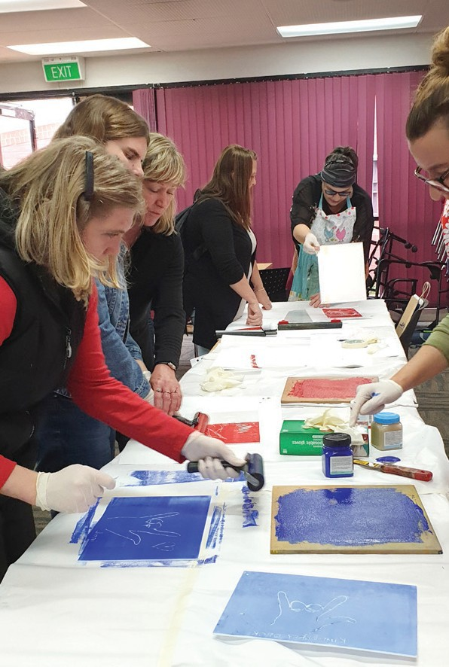
PWdWA has seen continuous requests by individuals and families for advocacy support in relation to NDIS. NDIS now represents over half of all issues dealt with by PWdWA.
ded
Deafblind Art Workshop
As part of the Western Australian Disability Coalition of advocacy and peak organisations, PWdWA undertook the lead in the systemic advocacy project “NDIS transition and interface issues”. The focus of the project, over an 18 month period, was to address the systemic barriers arising from the transition to NDIS in WA including issues with the NDIA policy and practices and other departments/mainstream agencies interface with the NDIS.
The project engaged with over 500 people with disability and families through peer groups, advocacy groups, the service sector, regional meetings, expos and a survey. As part of the project a diverse group of people with disabilities were engaged in a Co-design group that met on a regular basis and looked at solution-focused approaches to the issues both at an individual and systemic level. The Co-design group partnered with NDIA and NDIS Local Area Coordinator (LAC) Partners to discuss and Co-design recommendations to address issues that were raised during the project. This has culminated in the findings that are included in the report.
The findings from the project highlight issues with the flexibility of the scheme to deal with diversity and individual complex circumstances, as well as a lack of supports to navigate and connect people to the NDIS and service systems. The project used the principles from the NDIS Act 2013 as a foundation and found that the NDIA policy and practice does not always align with those principles.
The final report and recommendations were presented to the Hon Stephen Dawson MLC Minister for Disability Services, and Ed Duncan State Director of the NDIA on June 30 2020 at an afternoon tea with the Co-design group participants.
The full report with an Easy Read version with images and Easy Read text version of the Co-design report is available on the PWdWA website and printed copies available on request. A short video was produced to highlight the findings and is available on the PWdWA YouTube channel.

Projects

Housing Strategy
PWdWA continues to be a member of the Housing Advisory Roundtable. This year we presented on issues for people with disability through a specific deep dive roundtable on disability and mental health. Many of the issues on housing accessibility and support to find housing have been picked up through these forums and are being put into the State Housing Strategy
We provided further advice and attended workshops and meetings related to the transition process that will happen for group housing in WA and how Specialist Disability Accommodation (SDA) may be developed. We also partnered with Shelter WA and Summer Foundation on WA specific housing resources on SDA for participants and providers. Planned workshops were delayed due to COVID-19.
The Residential Tenancies Act in WA is currently being reviewed with scope for major changes. PWdWA did extensive research, interviews, and looked at previous advocacy on tenancy issues to inform our submission. We also had input into the potential improvement of boarding and lodging in legislation through our submission and through Shelter WA.

Employment
WA State government have set a target and strategy for increasing the number of people with disability employed in the public sector. PWdWA gave input to the strategy and have been pushing for a target over many years. This year saw PWdWA continue to raise the barriers to employment in the media, as well as sharing information on solutions through conferences and publications.

Access and Inclusion
PWdWA have continued to be active in the Perth Airport Access group, providing advice to the WA Electoral Commission, and through representatives to Metronet. Promotion of Co-design and inclusion of people with disability in governance structures
is the most successful way we can bring influence to projects. Over the year we have provided advice on numerous topics related to access and inclusion such as accessible tourism, inclusive University research centres, parking, and resilient and appropriate responses in disasters.

Justice
PWdWA provided input and advice to the Justice Bench Book on disability, which is used to provide advice to Judges. We also gave further input into the reform of the Criminal Law Mentally Impaired Accused Act, which has new legislation we hope will be going before parliament soon. The majority of our work in the justice space this year has been continuing to work towards having an independent third person available for people with intellectual and cognitive disabilities who are picked up by the police. This work has been in collaboration with Ethnic Disability Advocacy Centre (EDAC) and a specific project on Justice and Aboriginal People with Disability. A project to develop a pilot program and bring a working group together has been funded by the Department of Communities

Co-design of the State Disability Plan
PWdWA were engaged by the Department of Communities (DoC) via a grant for the development of a draft 10-year State Disability Plan through a Co-design process. PWdWA was requested to coordinate the Co-design process as well as contribute to the broad consultation of Phase 2 of the development of the strategy through connecting with ‘hard to reach’ groups to ensure representation through the process. A Co-design group was formed consisting of people from a broad range of backgrounds with diverse experiences of disability and held its first meeting in July 2019. A broad range of ‘hard to reach’ groups were identified including Culturally and Linguistically Diverse (CaLD), Aboriginal and Torres Strait Islander communities, prison communities, people with communication issues, and parents of children with complex behaviours, and engaged with as part of the project. The achievements of the project included a draft 10-year State Disability Strategy being finalised by the Co-design group and submitted to the Minister for Disability Services, the Hon. Stephen Dawson MLC, for sign-off, and the completion of the first draft actions and measurements as inputs to the first two-year action plan. PWdWA acknowledges and appreciates the significant contribution from the participants of the Co-design group throughout the project Michael New, Mark Blowers, Melissa Northcott, Angelo Cianciosi, Vanessa Vlajkovic, Sarah Langmead, Ingrid Moore, Kerry Elder and Wendy Wright, along with our project lead Suresh Rajan.

Systemic Advocacy Project: NDIS Transition and Interface Issues WA
The focus of the project over an 18 month period was to address the systemic barriers arising from the transition to National Disability Insurance Agency (NDIA) in WA, including issues with the NDIA policy and practices, and was funded by the DoC. The project engaged people with disability, peer groups, advocacy groups, the service sector, other government departments, CaLD community, and the wider community across the metropolitan and regional areas of WA to obtain feedback. A key part of the information gathering was through a long-running survey on the PWdWA website that gathered feedback from individuals, families and the community on their experiences of the National Disability Insurance Scheme (NDIS). A diverse group of people with disabilities were engaged in a Co-design group that met on a regular basis and looked at solution-focused approaches to the issues both at an individual and systemic level, partnering with NDIA and NDIS Local Area Coordinator (LAC) Partners to discuss and Co-design recommendations to address the issues raised. The findings highlighted issues with the flexibility of the scheme to deal with diversity and individual complex circumstances, as well as a lack of supports to navigate and connect people to the NDIS and service systems. During the course of the project, the findings have been used to inform submissions to government inquiries and the WA State Disability Strategy.

Member Engagement and Self Advocacy Project
PWdWA would like to thank the Member Engagement and Self Advocacy Project Co-design group for their assistance in developing and delivering the “Your Rights, Your Voice, Your Choice” self-advocacy course. The course, which ran from March to April 2020, was a great success and gave participants and Co-designers an opportunity to connect with others during lockdown, while learning about self-advocacy and sharing experiences. The Project also involved the development of PWdWA’s Community Engagement Plan. The Plan, due to be launched late 2020, has been guided by our members, staff and the greater community. The Plan will help to improve connections with community members and build upon our mission to advocate for the rights and empower people with disability in WA. This project was funded by a National Disability Insurance Scheme Information, Linkages and Capacity Building (NDIS ILC) Grant.

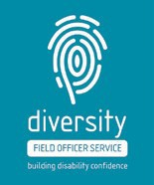
Diversity Field Officer
The Diversity Field Officer (DFO) project is an education and mentoring program working with small and medium sized businesses to help them feel more confident about disability inclusion in their workplace. It is funded by an NDIS ILC grant and is delivered in partnership with Advocacy WA (AWA). The businesses targeted by the project include tourism, retail and hospitality. During COVID-19, it became increasingly difficult to engage with businesses. We adapted and changed the way we worked with companies to maintain our connection and continue the project. This included carrying out a Business Analysis and Disability Friendly Premises Check virtually. A success of the project has been work done with the Mandurah boardwalk. This network of businesses on the Mandurah foreshore has been successful in making some effective and immediate changes. For example the Sebel Hotel is updating their evacuation plans to ensure they are inclusive and plan to add braille around the building.

Empowered, Connected and Co-Designed
The Empowered, Connected and Co-designed Project aims to increase the capacity of people with disability to make choices and transform those choices into desired actions and outcomes. It is funded by an NDISILC grant. The grant focuses on expanding what the organisation and Co-designers have already developed including our Co-design, On Board With Me, Health Rights and Your Rights, Your Voice, Your Choice workshops. We will do this through self- advocacy workshops, information sessions and building peer support in metropolitan, regional, and remote locations across WA. A Peer and Self-advocacy Engagement Project Officer was appointed at the end of March 2020. Since then, they have been working closely with other project and advocacy staff, developing resources and content. The Project will run until the end of 2022.

Reaching Out for Advocacy
hands-helping
The Reaching Out for Advocacy project focuses on raising awareness of disability advocacy in regional areas including the Wheatbelt, Great Southern and Southwest. It is funded by the DoC and delivered in partnership with AWA and Sussex Street Community Law Service (SSCLS). The PWdWA Regional Outreach Advocate was appointed in March 2020, and will be travelling to the regions to provide face-to-face individual advocacy and information sessions on topical issues. During COVID-19, travel to some regions was not possible so the project was promoted through a partnership with Linkwest, including a mailout to regional Community Resource Centres. Advocacy in Northam continued and regional networking was conducted electronically. We also worked to develop webinars so that information could be provided online.

Key Relationships

Thank you to the following organisations and agencies who have worked with us in various ways throughout the year!
Australian Federation of Disability Organisations
Advocacy WA
Advocare
Carers WA
Consumers of Mental Health Western Australia
Developmental Disability Western Australia
Department of Communities
Department of Social Services
Disability Advocacy Network Australia
Disability Leadership Institute
Ethnic Disability Advocacy Centre
Explorability
Health Consumers Council WA
Leadership WA
Legal Aid WA
Linkwest
McCusker Centre for Citizenship
Midlas
National Disability Insurance Agency
National Disability Services
Self Advocacy WA
Sexual Education Counselling and Consultancy Agency (SECCA)
Summer Foundation
Sussex Street Community Law Service
WA Council of Social Service
Western Australian Association of Mental Health
WA Individualised Services
Women with Disabilities WA
Youth Disability Advocacy Network
Your Say Uniting Care West

Treasurer’s Report

In the 2019 - 2020 financial year, PWdWA has fulfilled the majority of its Service Agreement obligations, however due to COVID-19 restrictions and the uncertainty of future individual advocacy funding, there has been a surplus. The surplus is due to a period with unfilled staff positions under our Department of Social Services (DSS) Advocacy, and planned travel to regional areas suspended within the Disability Royal Commission (DRC) Advocacy agreement and Department of Communities (DoC) Systemic Advocacy projects.
Text
New non-recurrent funds from DoC for the Consortium relate to a Waitlist Project to reduce advocacy waiting times and a Regional Outreach project. Both projects continue into the 2020-21 financial year.
The Diversity Field Officer Project, On Board with Me, and Empowering Health Consumers with Disabilities Projects funded from the DoC Information, Linkages and Capacity (ILC) Building grants were all completed on 30 September 2019. Small surpluses for each project were approved for ongoing use to meet project aims and have been partially used through our non-operating allocation, although COVID-19 limited full use this year.
PWdWA continued to receive funds from DSS for the National Disability Advocacy Program (NDAP) and National Disability Insurance Scheme (NDIS) Appeals Advocacy. These funds include supplementation in NDAP to fulfil obligations to our staff employed under the Social, Community, Home Care and Disability Services (SCHADS) award scheme. The DRC Advocate started this year and continues for the course of the DRC.
Our National Disability Insurance Agency (NDIA) funded projects all continue into the 2020-21 financial year.
The Department of Finance Connect with me Stage 2 Project concluded last year but the surplus was approved to do development of a Co-design policy. Small amounts of funding were also received from donations, interest, and provision of consultancy.
At the end of the 2019 - 20 financial year, PWdWA is in a good financial position. The Committee of Management remains active in overseeing the financial operation of the association. The audited accounts demonstrate that the organisation remains financially stable.
The Committee of Management and staff express thanks to Nulsen Independent Administration for payroll support and Patricia Loh Accounting for finanial management services throughout the year. We also sincerely thank Renata for her tireless work in Administration Support to PWdWA.
Adam Hewber
Treasurer

Income 2020 to 2021
- DOC - $1,933,084.00
- DSS - $563,089.00
- NDIA - $374,015.00
- Lotterywest - $58,000.00
- Other Grants - $36,723.00
- Other Income - $52,488.00

Expenses 2020 to 2021
- Salary and Wages - $1,427,296.00
- Paid to consortium - $811,010.48
- Admin and Operations - $712,070 .00

Income 2020 to 2022

Financial Statements

Please contact us directly for a screen reader accessible version of our financial statements.
City West Lotteries House 23/2 Delhi Street West Perth WA 6005
Ph: (08) 9420 7279
Country: 1800 193 331
Email: info@pwdwa.org

