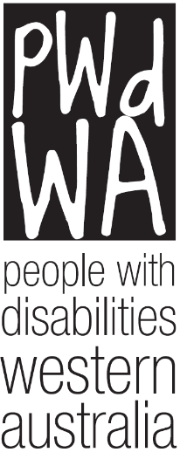

Can I access the NDIS:
The document has 7 questions that you can answer with Yes or No.
Click on the answer, and it will take you to the next question or give you the next step.

Am I aged 9 – 95?
  - Yes
  - No

Am I an Australian citizen, permanent resident, or Protected Special Category Visa holder?
  - Yes
  - No

Am I living in Australia?
- Yes
- No

Do I have a disability caused by a permanent impairment?
  - Yes
  - No

Do I need support to do everyday things?
  - Yes
  - No

Do I need some supports now to reduce my support needs in the future?
  - Yes
  - No

Do I need some supports now for my family to build their skills to help me?
  - Yes
  - No

NDIA partners can provide information and referral to existing community services.

NDIA partners can help you connect with other government and community supports.

Contact the NDIA for an access request form.

