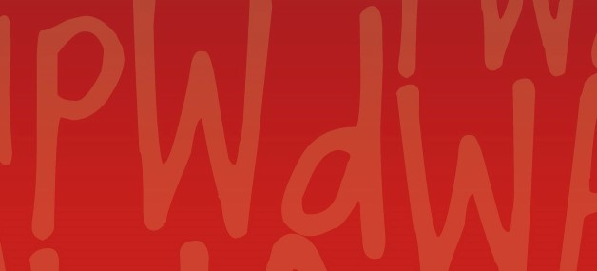
April 2021 Members Update
People With disabilities WA

Message from our Executive Director

Independent Assessments – PWdWA cautiously welcomes Minister’s Announcement
Along with the broader disability sector in WA, PWdWA expressed our deep concerns to the Federal and State Disability Ministers about the Federal Government’s intention to change how people with disability will access the National Disability Insurance Scheme (NDIS) with the introduction of independent assessments (IA) for NDIS participants announced in September 2020, by the then Federal Minister for NDIS, the Hon Stuart Robert MP.
In addition to correspondence to both Ministers, PWdWA in collaboration with Western Australia’s Individualised Services (WAiS) had undertaken consultation to inform written submissions to the NDIA Consultation Paper – Access and Eligibility Policy with independent assessments, and two submissions to the Joint Standing Committee on the National Disability Insurance Scheme – Inquiry into Independent Assessments under the NDIS.
It was therefore comforting to hear of the new Government Services Minister Linda Reynolds’ announcement last Thursday 15 April to shelve plans to roll out mandatory assessments until the end of trials and after nationwide consultations later this year.
PWdWA will remain extremely vigilant on this issue and along with the national disability advocacy sector, continue to monitor this issue to ensure that the views of our members are heard and acknowledged, and ensure that any proposed changes are consistent, fair and do not disadvantage anyone.

Australian National Construction Code – call for minimum standards
The Building Ministers’ Forum will decide in April 2021 whether an access standard for new housing construction should be included in the Australian National Construction Code and whether the design of housing should be suitable for all Australians, including older people and people with disability. PWdWA, in collaboration with the Australian Network for Universal Housing Design, has been lobbying the State Government to support the introduction of minimum standards at this meeting.
The State Government’s commitment under the State Disability Strategy for new social housing homes to be built to Liveable Design Housing Australia’s silver standards or higher to better support people with disability, is acknowledged and supported by PWdWA.
Nearly three-quarters of Australians with mobility impairment are unable to find housing that meets their needs. The decision by the Building Ministers will directly affect millions of Australian households with people with disability, older Australians, carers, children and people recovering from illness or injury.

PWdWA has called upon the State Government to support the inclusion of mandatory accessibility standards for the National Construction Code to provide more housing options for people with disability in WA.

Our submissions
You can find all our submissions at Our submissions | PWdWA

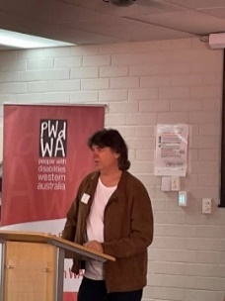

Special Event

Tony Sarre – Turning to White
On Saturday 27 March PWdWA presented “Turning to White” by Tony Sarre, which was a beautiful visual and audio described short film. Tony then spoke about the process of being a blind filmmaker. Attendees also were able to meet with some of our Committee of Management team and enjoy morning tea.

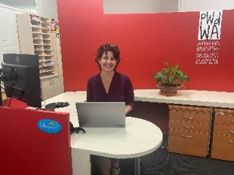

Lottery West Grant
PWDWA recently received an Information Technology Grant from Lottery West to upgrade all our computers to laptops along with new screens. The grant will allow our team to increase our organisational and service capabilities here in the office and allow for us to smoothly transition to working from home if the need arises.
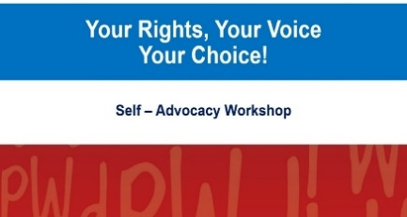

Your Rights, Your Voice, Your Choice

Self-Advocacy Workshops
Our free two-part face to face self-advocacy workshops, Your Rights, Your Voice, Your Choice will be held:

Face to Face
Thursday, 6 May and Friday, 7 May
Citiplace Community Centre (at the City Train Station),
12:00 pm – 5:00 pm.
Registration can be made through Eventbrite or by calling Vanessa on 08 9420 7279.
PWdWA Your Rights, Your Voice, Your Choice Weekday Course Tickets, Thu 06/05/2021 at 12:00 pm | Eventbrite

Online
Saturday 22 and 29 May 2021
Through ZOOM
10:00 am – 3:30 pm
Registration can be made through Eventbrite
PWdWA Your Rights, Your Voice, Your Choice Online Course Tickets, Sat 22/05/2021 at 10:00 am | Eventbrite
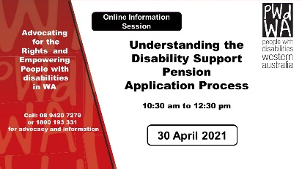

Understanding the Disability Support Pension Application Process

Online Information Session
We have produced this webinar in response to requests from our membership. This webinar will be especially useful to people who are about to apply for the Disability Support Pension (DSP). It will help you to be prepared and submit a strong application for DSP by understanding:
- if you are eligible to apply.
- the Centrelink DSP process.
- what information Centrelink needs to assess in your Application.
- what is good medical evidence and how to get it from your health professionals.
- things you need to know about the program of Support, Job Capacity Assessment and Disability Medical Assessment.
At the end of the webinar, you will have a good idea of how Centrelink will assess your application. We will also provide tools and links to additional resources that can help you.
Registration can be made through Eventbrite or by calling Vanessa on 08 9420 7279. PWdWA Understanding Disability Support Pension Application Process Tickets, Fri 30/04/2021 at 10:30 am | Eventbrite

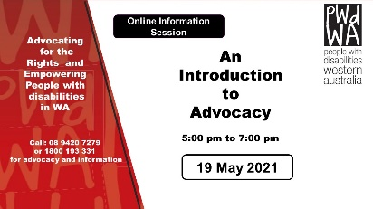

Introduction to Advocacy

Online Information Session
Advocacy is needed because:
- some people with disability are isolated and may not have support networks and have complex needs and situations.
- many people with disability and their families lack the knowledge they need to make a complaint or seek change.
- people may lack confidence and the communication skills they need to assert their rights and have their opinions heard.
- many people with disability fear that there might be negative consequences to making a complaint.
- people with disability are often seen as powerless and vulnerable and this becomes how we feel.
This online information session aims to explain different forms of disability advocacy, and how advocacy can work for you. Registration can be made through Eventbrite or by calling Vanessa on 08 9420 7279. PWdWA Introduction to Disability Advocacy Online Information Session Tickets, Wed 19/05/2021 at 5:00 pm | Eventbrite

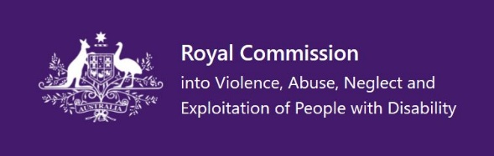

Royal Commission into Violence, Abuse, Neglect and Exploitation of People with Disability

Promoting Inclusion

Submission close date extended to 4 June
This issues paper is asking the public to share their views on what an inclusive society looks like. The paper asks nine questions and is available in Easy Read, PDF and DOCX.
Promoting inclusion | Royal Commission into Violence, Abuse, Neglect and Exploitation of People with Disability

The experiences of culturally and linguistically diverse people with disability

Submission close by 11 June
This issues paper is asking the public to share their views about the experiences of culturally and linguistically diverse people with disability. The paper asks thirteen questions and is available in Easy Read, PDF and DOCX.
The experiences of culturally and linguistically diverse people with disability | Royal Commission into Violence, Abuse, Neglect and Exploitation of People with Disability

Centre for Accessibility Australia

Launches Helpdesk
CFA Australia has launched a free service created to alleviate the hardship faced by people with disability due to inaccessible content called Helpdesk. The initial focus of the Helpdesk is to support people with disability who are unable to locate specific information or complete a specific task online due to accessibility issues by finding potential accessible alternatives. For example, if one grocery website is difficult to use, their disability-led team will identify accessible alternatives where possible.
If you are finding it difficult to do what you want online, please contact Helpdesk. Helpdesk - Centre For Accessibility Australia

PWdWA
PWdWA is run BY and FOR people with disabilities and aims to be the voice for all people with disabilities in Western Australia.

Free membership
If you know someone with a disability who would like to join our organisation, our membership is free for people with disability to become full members https://www.pwdwa.org/get_involved/become_a_member.html

Keep up to date with our regular posts to Facebook and Twitter
https://www.facebook.com/PeopleWithdisabilityWA/?ref=aymt_homepage_panel

