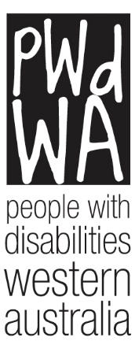

PWdWA

Newsletter

December 2022
- Message from PWdWA
- Christmas Hours
- PWdWA in Focus
- PWdWA in Action

Message from PWdWA

State Conference
PWdWA would like to that all the presenters and participants who attended our 2022 State Conference.
Over the two days, we heard some amazing presentations, all with the theme of Inclusive Communities. On day one, Uncle Vaughn McGuire welcomed us to country before Hon Don Punch MLA, Minister for Disability Services; Small Business; Fisheries; Seniors and Aging, officially opened our conference.. Drisana Levitzke-Grays, one of our keynote speakers, spoke passionately about accessibility for the deaf community and the importance of Auslan, while our other keynote speaker Dr Scott Hollier showed participants some of the latest digital accessibility features. Our breakout sessions for the day gave participants the option to hear from a wide variety of presenters, most of whom had lived experience.
Day two was opened by Department of Communities’ Director General Mike Rowe, followed by keynote speaker Julia Hales, who discussed the importance of authentic casting. The breakout sessions which followed were informative and thought-provoking. We would like to thank Senator Jordon Steele-John for coming along to chair the Royal Commission Update panel. In our last session for the day, Keynote speaker Wayne Herbert had us laughing as he spoke with passion and humour.
Over the next few weeks, we will be ensuring the video recordings of the conference are accessible, and we will be uploading them for people to access on Youtube. These will be available free of charge.

Christmas Hours
Our office will be closed from 12:30 pm Friday, 23rd December 2022, until 9:30 am Tuesday, 3rd January 2023, during the holiday period.
If you are in crisis, the following services are open over the holiday break:
Life-threatening emergencies:
- Police/ Ambulance/ Fire – 000

Counselling and support services:
- Lifeline – 13 11 14
- Crisis Care – 08 9223 1111 and 1800 199 008 (Country Free Call)
- Beyond Blue – 1300 22 4636
- 1800RESPECT – 1800 737 732
- Griefline – 1300 845 745
- Friendline – (08) 6118 0587

Emergency Relief:
- Emergency Relief and Food Access Service – 1800 979 777 (Monday to Friday, 9 am to 5 pm)
- WA Connect (Service Directory) https://waconnect.org.au/
- AskIzzy https://askizzy.org.au/

Mental Health/ Drug and Alcohol Support Lines:
- Mental Health Emergency Response Line – 1300 555 788 (Metro), 1800 676 822 (Peel), 1800 552 002 (Rurallink)
- Alcohol and Drug Support Line – 08 9442 5000 (Metro) or 1800 198 024 (Rural)
- Parent and Family Drug Support Line – 08 9442 5050 (Metro) or 1800 653 203 (Rural)

To search for local mental health support and advice and/or alcohol and other drug support and advice, search for services at https://myservices.org.au/.

PWdWA In focus

PWdWA Board Elects a New Chair
At their November meeting, the Board of PWdWA elected Yhana Lucas to the position of Chair. Yhana brings a wealth of cross-sector experience to the PWdDA board.
Yhana is a passionate advocate for all persons experiencing hardship, and having lived with hemiplegic cerebral palsy since birth; she is especially aware of the issues experienced by people with disabilities.
Born in Perth, she lived abroad for a year as part of a high school exchange scholarship, then moved interstate to study engineering at The University of Melbourne. While studying, she travelled internationally to compete in intervarsity debating championships and coached children and adults in public speaking.
PWdWA acknowledges and thanks Tom Monks for his significant contribution and exceptional leadership as Chair for the past 12 months.
In addition to being Board Chair, Mr Monks served as a member of both the Tenders and the Finance and Risk sub-committees.
Through these roles, Mr Monks was instrumental in several projects that are future-proofing PWdWA's service delivery.
This included PWdWA's successful tender as Consortium Lead for a further three years of State Government funding, with Mr Monks particularly pivotal in strengthening the Consortium governance arrangements.
PWdWA wishes Mr Monks all the best with his future endeavours.

PWdWA in Action

Free RATs
The Department of Communities has given PWdWA a number of nasal and lollipop RATS for people with disability. If you would like to access some of these, Vanessa will be in the office every Tuesday and Wednesday from 2 January between 9:00 am and 2:00 pm. If this time is not convenient for you, please get in touch with Vanessa at 9420 7279 ext 717 or email vanessa@pwdwa.org to arrange a time for you to collect them. PWdWA’s address is City West Lotteries House, Unit 23, 2 Dehli Street, West Perth. The closest train station is City West on the Fremantle line.

International Day for People with Disability
PWdWA recognises that people with disability are often asked to complete surveys and give feedback on their lived experiences, and we wanted to honour and celebrate the contribution that is made to the community when this is done.
This past year, every PWdWA member who completed one of our surveys or contacted us when we asked for your feedback on our issues papers was put into a draw. In November, we drew out the names of twenty members and invited them to lunch with us to celebrate International Day for People with Disability.
On 3 December, twenty of our members joined PWdWA CEO Brendan Cullinan at City West Lotteries House, where they enjoyed some delicious food and drinks, great conversation and had the opportunity to speak about their concerns.

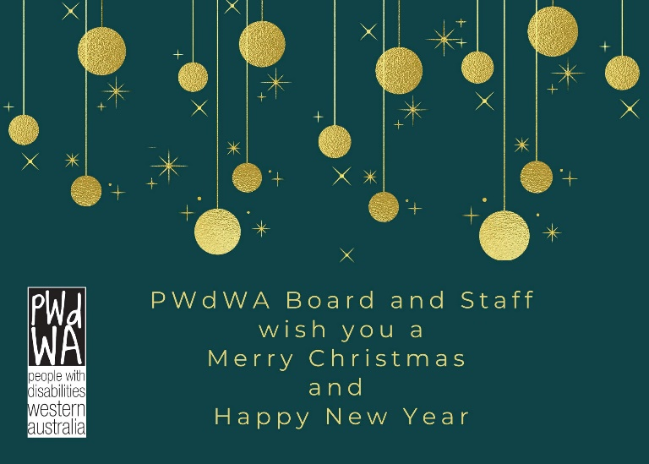
PWdWA is funded by the Western Australian Department of Communities and the Australian Department of Social Services.
PWdWA is run BY and FOR people with disabilities and aims to be the voice for all people with disabilities in Western Australia.

