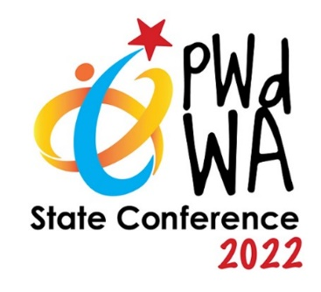
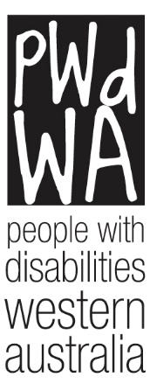

PWdWA

Newsletter

May 2022
- Message from our CEO
- Current Issues
- PWdWA Profile
- PWdWA in Action
- Upcoming

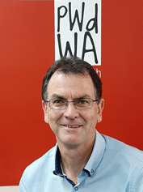
Message from our CEO Brendan Cullinan

Time for Action
I am sure, like most people, we are glad that the election campaigning is over and we have some direction moving forward. While a Labor victory has been achieved, at the time of writing, Labor is still one seat away from achieving a majority, with three seats still to be decided.
The challenge for Prime Minister Albanese and his government is to put words into actions now, particularly when it comes to Labor’s commitment to fix the National Disability Insurance Scheme (NDIS).
To remind the Prime Minister, Labor made the following six-point commitment to fix the NDIS:
- Labor will revitalise the National Disability Insurance Agency: Labor will lift the staffing cap at the NDIA, commit to urgently reducing insecure labour-hire arrangements, increase permanent staff at the agency, and improve the culture. Labor will also review NDIS design, operation and sustainability.
- Stop the waste: Labor will review the excessive use of external lawyers, a crackdown on criminal activity and fraud, and review the value for money of lucrative consultancy contracts.
- Boost efficiency: Streamline the planning process for better initial plans. Fix the planning pathway and appeals to make NDIS decision-making more efficient, fair, and investment focused.
- Stop the unfair cuts: Labor will introduce an expert review that will guarantee plans will not be arbitrarily cut.
- Fixing regional access: Labor will appoint a senior officer within the NDIA to tackle the concerning barriers to service delivery in regional areas of Australia.
- Put people back into the NDIS: Labor commits to co-designing changes to the scheme with people with disability and the sector, boost the number of people with disability on the board of the NDIA.
Beyond these commitments, Labor also pledged to:
- Increase advocacy funding.
- More flexible housing.
- Boost employment for people with disability.
- No one is left behind by measuring action against the National Disability Strategy and other related strategies and research.
Labor has achieved a victory with a low primary result of 32%. If Labor fails to deliver on its election commitments, it runs a high risk of being a one-term government. While personally for the Prime Minister Albanese and his government, this may be a setback for their party and their political careers, for many Australians, failure to deliver on their election commitments will be catastrophic. Failure to deliver on the commitment to fix NDIS will result in thousands of people with disability, their families and carers continuing to navigate and be blocked by an unfair and inequitable system, denying them the basic human right of choice and control in their lives.
PWdWA, along with the disability sector nationwide, will be monitoring and holding the Labor government accountable to its commitments.
Prime Minister Albanese said in his victory speech,” No one left behind because we should always look after the disadvantaged and the vulnerable. But also, no one held back because we should always support aspiration and opportunity. That is what my government will do.”
Well, now it’s time to do!

Current Issues
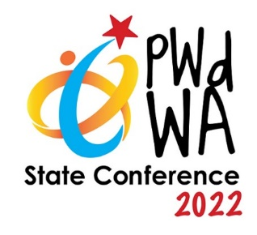

PWdWA State Conference 2022
PWdWA is excited to announce that the Department of Communities will sponsor our 2022 State Conference. Led exclusively by people with lived experience of disability, mental health issues and neurological differences.
This year’s theme is “Inclusive Communities”, focusing on developing and strengthening the self-advocacy and capacity of people with disability.
The conference will provide a platform for addressing contemporary and emerging issues and a forum for collaboration and exchanging ideas.

PWdWA Conference 2020 - Call for Content
PWdWA is now inviting content submissions for conference sessions for the PWdWA State Conference 2022.
​Anyone can suggest content
​Anyone can submit a proposal for any session they would like to present personally or see presented at the conference. You do not need to be an academic, and you don’t need to have presented at a conference before!
​Theme and streams
The theme for the PWdWA State Conference 2022 is “Inclusive Communities”. The three conference streams are:
- ​​​Collaboration
These sessions will analyse and discuss emerging issues, collaboration and working together.
- Celebrations
​These sessions will showcase innovation and best practice.
- Choice
These sessions will provide opportunities for input and learning
​Proposal Criteria
All proposals will be considered, but we are especially looking for proposals for sessions which:
- ​​Link with the conference theme and one of the conference streams.
- Have not been offered in WA before.
- Can demonstrate an interactive, participative format.
- Feature the voices of lived experience.
​Before planning your submission, please read these Call for Content Guidelines to ensure your proposal suits the conference format. Please contact Vanessa on 9420 7279 ext 717 for the guidelines in a different format for your accessibility.
​To make a session submission go to click here.
Potential participants who need support or assistance in planning or preparing their submission are invited to contact us at jane@evolvewa.com.au
​Submissions must be received by 4 pm on Thursday, 30 June 2022, and applicants will be advised in mid-August 2022 whether or not their proposed session will be included in the program.

​PWdWA Profile

Isabella Choate – Economic Participation Project
Isabella (she/they) has joined the PWdWA team as our Economic Participation Officer, taking over from Felix, who has left PWdWA to begin an adventure on Kangaroo Island.
The Economic Participation Project aims to connect young people with disability to potential employment opportunities in targeted sectors within regions. The project will aim to build the capacity and confidence of small to medium-sized businesses to be more welcoming, confident and accessible to people with disability and to link these businesses to young people with disability seeking employment in that sector.
Isabella works across the Youth, Mental Health, Alcohol and Other Drug and Disability sectors to advocate for understanding and celebrating intersectionality. They work in Youth Consultancy, utilising their lived experience to bring an informed perspective and being a Project Officer, Educator, and Co-Design Facilitator. Isabella also volunteers as an Independent Visitor to prisons, is a member of the grassroots organisation Boorloo Justice, and is co-chair of the Youth at Risk Network Action Group.
Isabella is completing her Honours in Psychology, Cert IV in Mental Health Peer Work, and has a Graduate Certificate in Digital Marketing.

PWdWA in Action

Disability Royal Commission – The impact of and responses to the Omicron wave of the pandemic for People with Disability Submission
PWdWA provided comment to the Disability Royal Commission on the experiences of people with disability in WA during the Omicron wave of the COVID-19 pandemic.
You can read our submission in either PDF or Word versions at Our submissions | PWdWA or contact Vanessa on 9420 7279 ext 717 for a version accessible for you

Department of Communities Western Australia – Disability Access and Inclusion Plan (DIAP) Feedback
Our submission to the Department of Communities on the goals set out in WA State Disability Strategy 2020 – 2030 provided feedback on creating an accessible and inclusive service. You can read our submission in PDF or Word versions at Our submissions | PWdWA or contact Vanessa on 9420 7279 ext 717 for a version accessible for you.

Systemic Advocacy Survey
Did you know that when you complete a PWdWA survey, it directly informs our submissions and systemic advocacy?

Systemic advocacy is an important part of PWdWA’s work. It is important for us to understand what areas of systemic advocacy you think we need to focus on.

PWdWA invites our members to have their say on our systemic advocacy work. This survey will help inform our priority areas for systemic advocacy and ensure your voice is heard when we are advocating for people with disabilities in WA.

If you need help with the survey, please contact Vanessa on 9420 7279. We can also arrange for the questions to be provided via email, SMS, Facebook messenger or other alternative forms of communication.
You can find the survey online.

Upcoming

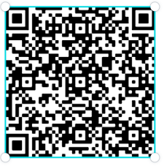

PWdWA’s Eventbrite Home Page
Do you want to know what events PWdWA has coming up? Hold your phone camera over the QR code, then click on the link that is shown. This will take you to our Eventbrite home page.

PWdWA’s Disability Royal Commission Information Session

Monday 20 June 2022 1:00 pm – 3:00 pm
This Information Session will explain the goals and scope of the Disability Royal Commission. Participants will learn how they can tell their story, what supports are available and who can help.
An advocate will be available after the presentation to provide general advice; if you require specific personal advice, please contact the duty advocate on 94207279 or dutyadvocate@pwdwa.org to make an appointment with the DRC advocate.
You can register for this event through Eventbrite; if you do not wish to use Eventbrite, contact Vanessa on 9420 7279 ext. 717 or email vanessa@pwdwa.org.

Wednesday 27 July 2022 10:00 am – 2:00 pm.
If you cannot make our June session, this webinar will also be run in July;

PWdWA’s Disability Support Pension Online Information Session

Wednesday 22 June 2022 10:00 am – 12:00 pm
This session will benefit people about to apply for the Disability Support Pension (DSP). It will help you prepare and submit a robust application for DSP by understanding:
- If you are eligible to apply.
- The Centrelink DSP process.
- What information does Centrelink need to assess in your application.
- What is good medical evidence, and how to get it from your health professionals.
- Things you need to know about the program of Support, Job Capacity Assessment and Disability Medical Assessment.
At the end of the session, you will have a good idea of how Centrelink will assess your application. We will also provide tools and links to additional resources to help you.
You can register for this event through Eventbrite or call Vanessa on 9420 7279 ext. 717 or email vanessa@pwdwa.org.
If you cannot attend this session, the webinar will be held on Monday, 4 July 2022, 10:00 am – 12:00 pm.

PWdWA’s NDIS Reviews and Appeals Online Information Session

Monday 27 June 2022 1:00 pm – 3:00 pm
- Do you want to know more about NDIS reviews and appeals?
- Do you want to understand when and how you can ask the NDIS to change their decisions?
Rachel, our lived experience facilitator and former NDIS appeals advocate has a wealth of knowledge.
We have produced this information session in response to requests from our membership.
This session is for Western Australians living with disability, their families, friends and carers assisting them.
You can register for this event through Eventbrite or call Vanessa on 9420 7279 ext. 717 or email vanessa@pwdwa.org.

PWdWA
PWdWA is run BY and FOR people with disabilities and aims to be the voice for all people with disabilities in Western Australia.
Free membership
Being a member of PWdWA gives you the opportunity to be involved in shaping our organisation through our planning and evaluation processes. As a member, you can make sure the issues that matter to you are heard by being involved with our submissions and advocacy campaigns. Voting is restricted to full members aged 15 years and above.
Full Membership is available to persons living in Western Australia, with a disability, over 15 years who are Australian citizens or permanent residents of Australia.

