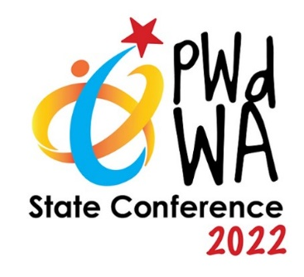
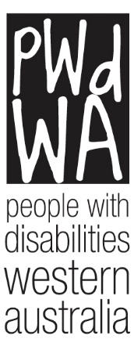

PWdWA

Newsletter

November 2022
- Message from PWdWA
- Current Issues
- PWdWA in Focus
- PWdWA in Action
- Upcoming

Message from PWDWA

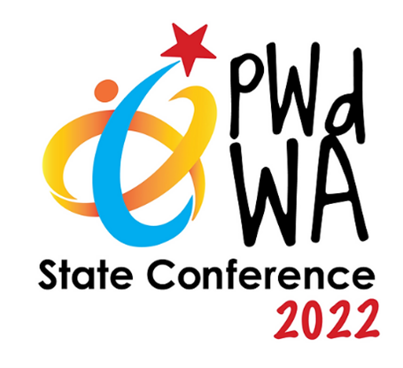

State Conference
It is less than a month until our State Conference, and the Conference Organising Committee has been busy finalising the details.
Our MC for the two-day event will be Phoebe Kingston, with our opening address on Wednesday by Hon. Don Punch MLA and on Thursday by Mike Rowe AM, Director General Department of Communities.
Senator Jordon Steele-John will Chair a panel on the Disability Royal Commission. Other panel discussions will be held on Disability Legal Issues and Sports and Recreation Inclusion and Accessibility.
The Disability Health Network will present Hospital Stay Guidelines to inform you of your rights and assist you in self-advocating. While Cassandra Hughes, CEO of Down Syndrome Western Australia, will discuss their new app, designed by Down Syndrome WA to provide resources for people with down syndrome, their families, carers, and medical and allied health supports. Elaine and Joy from Consumers of Mental Health WA will lead hands-on activities to build confidence and capacity for people with mental health challenges.
You can register for the Conference at https://www.pwdwaconference2022.org.au/register.

Travel Subsidies now available for our State Conference
On 3 November, Hon. Don Punch MLA, Minister for Disability Services; Fisheries; Small Business; Seniors and Ageing, came along to PWdWA to present a Lotterywest grant that will assist Regional and Metro Western Australians with disability with the cost of travel to the conference.
PWdWA would like to thank Lotterywest for becoming a Major Supporter of the PWdWA State Conference 2022 – Inclusive Communities.

Regional and Metropolitan Western Australians with disability can now apply for travel subsidies to assist them in attending the conference through the Conference Website https://www.pwdwaconference2022.org.au/.

If you require assistance completing the online application, please contact Vanessa at 9420 7279 ext 717 or email vanessa@pwdwa.org.
Image description left to right: Brendan Cullinan, CEO; Renata Krollig, Administration Officer; Nihal Iscel, Vice Chair of the Board; Hon. Don Punch MLA; Vanessa Jessett, Communications Officer; Idil Sudi, Individual Advocate; Chris Chambers, Project Officer.

Current Issues

Joint Standing Committee Inquiry
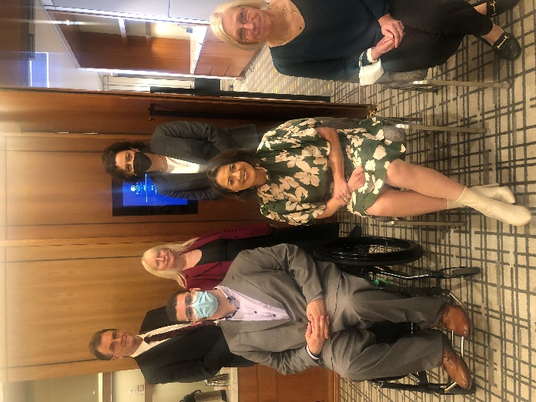
PWdWA was invited to provide evidence to the Joint Standing Committee on the National Disability Insurance Scheme inquiry into the Capability and Culture of the NDIA held in Perth on Monday, 14 November 2022.
CEO Brendan Cullinan and Individual Advocate Julie Bloomfield provided evidence that while the Scheme had provided support for many eligible people with disability, there are a number of major concerns that need to be addressed.
Terms of reference:
• the capability and culture of the National Disability Insurance Agency (NDIA), with reference to operational processes and procedures and nature of staff employment.
• the impacts of NDIA capability and culture on the experiences of people with disability and NDIS participants trying to access information, support and services from the Agency.
Image Description - Back row; Brendan Cullinan, CEO, PWdWA; Erika Webb, Deafblind West Australians; Dr Monique Ryan MP, Independent, Kooyong Victoria Front row; Senator Jordon Steele-John, Chair, Libby Coker MP, Australian Labor Party, Corangamite, Victoria; Julie Bloomfield, Individual Advocate, PWdWA.

PWdWA In focus

Our New Board Members
On Wednesday, 26 October, at the PWdWA Annual General Meeting (AGM), three of our members joined PWdWA’s Board. PWdWA welcomes Eric Casey, Frank Smith and Grace Barnes as they continue to uphold our motto of by people with disability for people with disability.

Our New Staff Members
PWdWA would like to extend a warm welcome to three new members of the PWdWA team. Andrea has joined our team as Operations Manager, while Lisa and Nicola join us as Individual Advocates.

PWdWA in Action

LeadAbility Panel
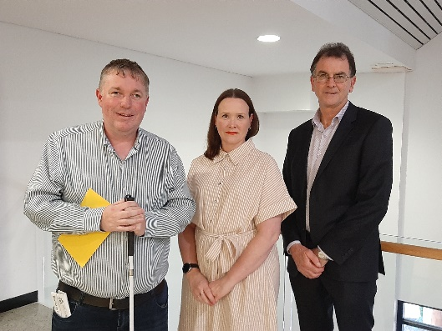
PWdWA's CEO, Brendan Cullinan, was invited by Leadership WA as part of a panel with Dr Scott Hollier from Centre of Accessibility Australia and Kristie Kent, Manager People and Culture at Landgate, to discuss his views on leadership, citizenship and co-design with participants of the LeadAbility Course.
LeadAbility is an interactive Course designed to develop the capacity of people with disability, or those in the sector, who have demonstrated potential to lead or generate change.
Image description: Dr Scott Hollier, Kristie Kent, and Brendan Cullinan.

Upcoming

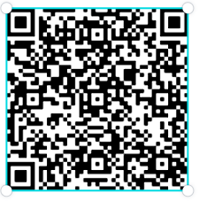

PWdWA’s Eventbrite Home Page
Do you want to know what events PWdWA has coming up? Hold your phone camera over the QR code, then click on the link. This will take you to our Eventbrite home page.

PWdWA Your Rights, Your Voice Your Choice Face-to-Face Workshop

Friday, 25 November, and Monday, 28 November, 10:00 am – 3:00 pm
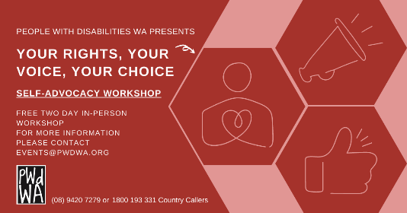
Our free Self-Advocacy face-to-face workshop will be held over two days.
This workshop will introduce attendees to Self-Advocacy and build the necessary self-advocacy skills. This workshop is a two-day commitment, and a certificate will be awarded upon completion.
• Understand your rights and the different types of advocacy
• Learn the critical steps to becoming a successful self-advocate
• Explore ways to communicate and how to be more assertive
• Share real experiences and learn from others
You can register for this event through https://www.eventbrite.com.au/e/430736292847or call Vanessa on 9420 7279 ext. 717 or email vanessa@pwdwa.org.

PWdWA’s Disability Support Pension Online Information Session

Monday, 12 December 2022, 10:00 am – 12:00 pm
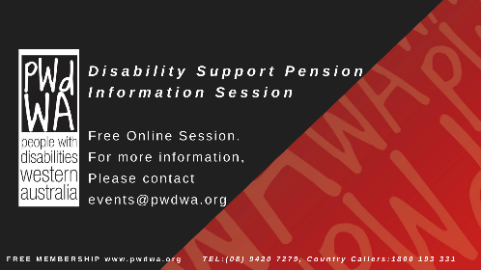
This session will inform people about how to apply for the Disability Support Pension (DSP). It will help you prepare and submit a robust application for the DSP by understanding the following:
- If you are eligible to apply.
- The Centrelink DSP process.
- What information does Centrelink need to assess in your application?
- What is good medical evidence, and how to get it from your health professionals?
- Things you need to know about the program of Support, Job Capacity Assessment and Disability Medical Assessment.
At the end of the session, you will have a good idea of how Centrelink will assess your application. We will also provide tools and links to additional resources to help you.
You can register for December’s session at https://www.eventbrite.com.au/e/pwdwas-disability-support-pension-online-information-session-december-registration-430731498507 or call Vanessa at 9420 7279 ext. 717 or email vanessa@pwdwa.org.
PWdWA
PWdWA is funded by the Western Australian Department of Communities and the Australian Department of Social Services.
PWdWA is run BY and FOR people with disabilities and aims to be the voice for all people with disabilities in Western Australia.

