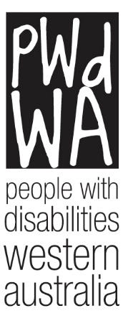

PWdWA

Newsletter

February 2023
- Message from our CEO
- Current Issues
- PWdWA in Action
- PWdWA in Focus
- Upcoming

Message from our CEO – Brendan Cullinan
The start of 2023 has been another busy period for PWdWA Board and staff. PWdWA recently reviewed and endorsed the Disability Advocacy Network Australia submission on A New Act to Replace the Disability Services Act 1986. Future systemic work includes involvement in the review of the transport standards and the NDIS review. The PWdWA Board recently held its strategic review workshop, which provided an opportunity to reflect on achievements and set future priorities that include a strong focus on membership growth and engagement. PWdWA staff will continue to deliver online and face-to-face workshops on a number of topics which are detailed later in this newsletter. A review of our IT systems will be implemented to ensure fit-for-purpose and improve integration. This review process will include an upgrade of the PWdWA website to be more contemporary with the design and improve accessibility to information.

Page 1

Current Issues

Facebook Posts
In recent months PWdWA has uploaded several access and inclusion information posts on Facebook. These have been a great success, and we intend to continue.
We would love to hear from our members about what they want the Western Australian community to be aware of when it comes to inclusion and accessibility.
Is there a topic you would like us to talk about? Or is there an etiquette regarding your disability you want people to know? Please send your ideas to Vanessa at 9420 7279 or vanessa@pwdwa.org.

PWdWA in Action

Strategic Review Workshop
On 11 February, the PWdWA held a Strategic Review Workshop to reflect on its achievements under the current Strategic Plan (2021-2026) and establish future strategic priorities to enhance membership engagement and advocacy work.
Digital Inclusion Blueprint
PWdWA has become a member of the Western Australian Governments Digital Inclusion Accord.
PWdWA attended the launch of the Digital Inclusion Blueprint on Friday, 16 December 2022.
The blueprint aims to make digital technology and accessing online services easier for all Western Australians.
You can read the blueprint at https://www.wa.gov.au/organisation/department-of-the-premier-and-cabinet/office-of-digital-government/digital-inclusion.
Page 2

PWdWA In Focus

Our Team
2022 saw some changes in our team, so we thought it was time for a bit of an update on who’s who: CEO - Brendan Cullinan; Operations Manager – Andrea Surman; Individual Advocacy Manager – Lisa Hook; Individual Advocates - Elisha Johnson, Glenda Bye, Idil Sudi, Julie Bloomfield, Lisa Thomas, Mark Huston, Nicola Brown; Project Officers – Chris Chambers and Melissa Higgins; Admin Officer – Renata Krollig and Communications Officer – Vanessa Jessett. Brianna Domeracki is currently on parental leave.

Upcoming

PWdWA’s Eventbrite Home Page
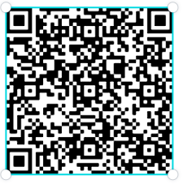
Do you want to know what events PWdWA has coming up? Hold your phone camera over the QR code, then click on the link. This will take you to our Eventbrite home page.

PWdWA NDIS Reviews and Appeals Online Information Session

Friday, 3 March 2023, 1:00 pm – 3:00 pm
- Do you want to know more about NDIS reviews and appeals?
- Do you want to understand when and how you can ask the NDIS to change their decisions?
We have produced this information session in response to requests from our membership.
Page 3
This session is for Western Australians living with disability, their families, friends and carers assisting them.
You can register for this event through https://www.eventbrite.com.au/e/505734374127 or call Vanessa at 9420 7279 ext. 717 or email vanessa@pwdwa.org.

Upcoming Information Sessions and Workshops
PWdWA will hold the following information session and workshops in March and April.
- 24 March - NDIS Reviews and Appeals Online Information Session
- 30 and 31 March - Self Advocacy Workshop Online
- 14 April - DSP Information Online Session
- 21 April - NDIS Reviews and Appeals Online Information Session
- 27 and 28 April – Co-Design Face-to-Face Workshop
Registrations will soon open, so keep a look out on our Eventbrite and Facebook pages.
PWdWA
PWdWA is funded by the Western Australian Department of Communities and the Australian Department of Social Services.
PWdWA is run BY and FOR people with disabilities and aims to be the voice for all people with disabilities in Western Australia.
Page 4 End.

