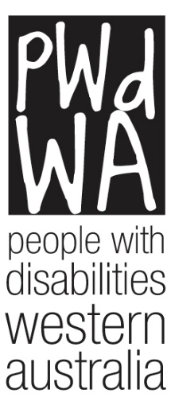

Submission
Submission on the purpose, intent and adequacy of the Disability Support Pension (DSP)
Senate Standing Committee on Community Affairs
People with Disabilities (WA) Inc. (PWdWA) would like to thank the Senate Standing Committee on Community Affairs for the opportunity to provide comment for their review into the purpose, intent and adequacy of the DSP.

President: Lisa Burnette
Executive Director: Brendan Cullinan
Author: Brianna Lee and Leia Robinson
People with Disabilities (WA) Inc.
City West Lotteries House, 23/2 Delhi Street West Perth WA 6005
Email: brendan@pwdwa.org
Tel: (08) 9420 7279
Country Callers: 1800 193 331
Website: http://www.pwdwa.org

People with disabilities WA (PWdWA)
Since 1981 PWdWA has been the lead member-based disability advocacy organisation representing the rights, needs, and equity of all Western Australians with a disability via individual and systemic advocacy. We provide access to information, and independent individual and systemic advocacy with a focus on those who are most vulnerable.

PWdWA is run BY and FOR people with disabilities and aims to empower the voices of all people with disabilities in Western Australia.

Introduction
“Government right now don't care for the rights and welfare of disability community.”

Access to social protections and an adequate standard of living is a fundamental human right. Australia is a signatory to both the International Covenant on Economic, Social and Cultural Rights (ICESCR) and the United Nations Convention on the Rights of Persons with Disabilities (UNCRPD). Article 9 of the ICESCR recognises the right of everyone to social security and Article 28 of the UNCRPD guarantees people with a disability have access to an adequate income when they cannot participate in paid employment.

Although not yet finalised, economic security remains a key outcomes area for the new National Disability Strategy (NDS). In fact, initial consultation around the NDS found that people with disabilities felt economic security had gotten worse in the last 10 years. Importantly the consultation found that 84% of respondents had issues with ‘Having enough money to pay for daily expenses’ (with 65% of respondents indicating it was a major or severe issue) and that people believe that “fair and equitable access to the Disability Support Pension (DSP) was critical.” Given these extremely concerning findings it is important to highlight that the last 10 years has also seen access to the DSP significantly eroded through a number of legislative and policy reforms. We do not believe it is a coincidence that following these reforms people with disabilities feel their economic security is worse off.
PWdWA receives both state and federal funding to provide advocacy around issues experienced by the community, including the DSP. In the last 5 years, PWdWA has supported over 400 people with disabilities in WA with advocacy issues related to DSP applications and appeals. During this time, it has consistently been one of our top trending issues for individual advocacy. The key issues that people are seeking advocacy for are understanding the eligibility criteria and accessing evidence which demonstrates they meet the DSP. Unfortunately, it has been our experience that the current eligibility criteria and application process precludes many people with a disability who will not be able to find or maintain employment. These people are therefore expected to meet the increased cost of living with a disability on the JobSeeker/Newstart subsidy which places them into financial insecurity and often poverty.
The DSP is one of the main mechanisms for the Australian government to ensure economic security and basic standards of living for Australians with a disability. As it currently stands, if the DSP does not undergo significant reforms Australia will fall short of meeting the outcomes proposed under the new NDS and continue to place people with disabilities’ human right to economic security at risk.

Submission Format
PWdWA has contributed more broadly to the submission which is being provided to the Senate Standing Committee on Community Affairs by the Australian Federation of Disability Organisations (AFDO).
As part of our role in ensuring people with a disability in WA have a voice in the issues that matter to them, we published an online survey to help community members have a say for this enquiry. The survey asked the people with a disability in WA to tell us about their experiences applying for the DSP and receiving employment supports.
Forty-two people responded to our survey. Of those 42 people 83% had applied for, or assisted someone to apply for, the DSP. Almost half of the respondents were people with a disability, with other respondents being family members, friends, or carers. We have presented the results of the survey according to the themes raised by respondents. We have expanded further on the themes raised by respondents based on the experiences of the over 400 people we have supported through our Individual Advocacy, drawing attention to how these themes relate to the overall issues with the design and implementation of the DSP eligibility criteria.

Recommendations
PWdWA Supports AFDOs eight key recommendations for fair, reasonable and sustainable DSP.
- All persons have a human right to social security and social protection. The right to social security is also a core right of national citizenship in Australia that has long been embedded in legislation and government policy (e.g., Invalid and Old-aged Pension Act, 1908).
- The right to social security and social protection does not deny the right to work for persons with impairment/s and/or chronic condition/s but recognises that across the life course, persons with disability will require differing levels of socio-economic support to account for changes in personal circumstances and in the labour market.
- Persons with disability who are unable to work or are limited in their capacity to work due to impairment, have a right to social protection and economic security (CRPD Art. 28). Mainstream unemployment benefits and income support payments are inappropriate and not fit for purpose as social security payments for persons with disability.
- The assessment of disability social security eligibility needs to be fair, reasonable, and based upon an objective measure of need to ensure it is first, responsive to the individual and their circumstances, and second, does not generate hardship or greater economic insecurity.
- Disability social security assessment processes should be undertaken by relevant medical and allied health professionals who have the required expertise in relation to the individual’s impairment/s and chronic condition/s alongside the everyday impacts the impairment/s and/or chronic condition/s have over a period of time and the impacts of social barriers like stigma, discrimination and inaccessibility of the labor market.
- Personal information and evidence provided by the assessing medical and allied health professionals, and the individual concerned, remains protected under national privacy legislation and cannot be shared nor drawn upon without the explicit permission of the individual concerned (CRPD Art. 22).
- Disability social security assessment processes, procedures and outcomes must be freely and readily available and distributed widely in inclusive accessible formats and languages to ensure that all persons with disabilities, their support networks and medical and allied health professional support networks are fully informed (CRPD Art 21).
- Responsible government department/s should publish regular and comprehensive de-identified data documenting the core demographic information of recipients alongside changes to regulations and guidelines to enable, first, the monitoring of impact of such changes, and second, to ensure that persons with disabilities and/or chronic conditions, medical and allied health professionals, and relevant organisations are fully informed at all times (CRPD Art 31). The data should be in a form that allows for secondary analysis by independent parties.
Key Areas Where Change is Needed
- Reinstate the process where Treating Doctors were requested to respond to relevant questions, rather than a blanket request for medical files.
- Ensure that the view of a Government Contracted Doctor is not treated as determinative without the delegate looking at other material including giving real weight to treating doctor’s reports.
- Remove the wording “Treated and Stabilised” from the Eligibility Requirements.
- Remove the Program of Support for the DSP Eligibility Process.
- Implement a set of Publicly Available Standards regarding the time it takes to process a claim for the DSP and for the time it takes to complete a review.
- Review the Content of the Impairment Tables so that they become a tool to assist eligibility rather than acting as a barrier to eligibility.
- Reinstate regular publicly available reporting on all aspects of the DSP including claims and reviews.

Purpose of the DSP
The DSP is supposed to be an income support payment for people who are unable to work due to permanent physical, intellectual, or psychiatric impairments. On face value this statement seems reasonable, however the way it is interpreted and implemented has created a system which deliberately creates barriers for people with a disability to accessing income support.
In fact, many of the legislative changes over the last 10 years have been specifically designed to decrease the “financial burden” of disability on the government without any adequate review as to the impact those measure have had on the rights of people with disability to economic security. The current review of the Impairment Tables is a clear example of the government’s lack of transparency and accountability. The review does not seek to understand the impact of the changes to the Impairment Tables that were introduced in 2011, instead only the Tables functionality.
Similarly, the purpose of the Program of Support, a key component of DSP eligibility, is to help people with a disability to prepare for, find and keep a job. Instead, it is acting as a barrier or delay mechanism to DSP access, and there is no evidence from the government that it is achieving its intended purpose of putting people into employment, so they do not need the DSP.

Accessing the DSP

“It's an impossible process for people who are not in crisis but impossible for people who are”

We asked people to tell us about their experiences of applying for the DSP. We wanted them to tell us what was easy about the process and what was hard. We note that the only part of accessing the DSP that some respondents found easy was finding the forms. Overall, all respondents indicated there was nothing easy about applying for the DSP.

Understanding the DSP eligibility criteria
The majority of respondents (77.5%) found it either hard or very hard to understand the DSP eligibility criteria.
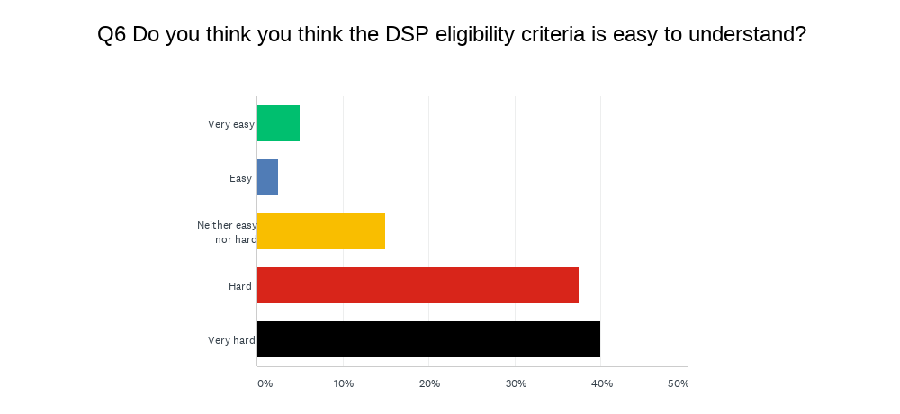

Respondents spoke about the lack of clarity around finding information on the criteria, understanding them, whether they meet it, what evidence they require, and how the impairment tables applied, especially where they had multiple diagnosis.
They make it impossible to find the actual criteria you need to meet and terms used in the little information they do provide are vague and have no explanation.
Complex questions that some individuals would not comprehend and lack of support to those applying, turn around time frame. Understanding the 20point system or understanding of fully treated and stabilised
PWdWA Survey Respondents
This lack of understanding about the actual criteria is reflected in the results of our question asking respondents to identify which parts of the eligibility criteria for the DSP they understand.
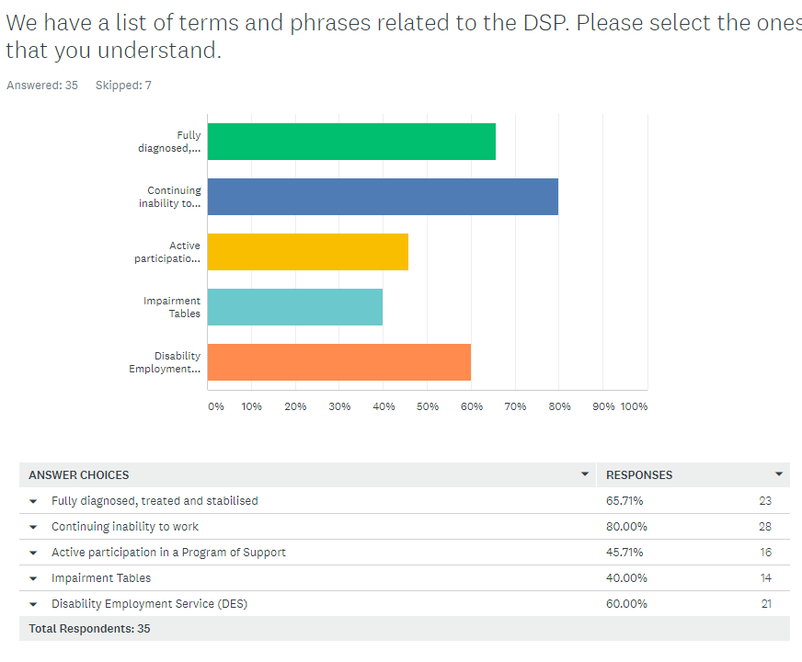
Significantly, less than half of the survey respondents understood the Impairment Tables or Active participation in a Program of Support (POS). These are key components of the DSP eligibility criteria and are significant barriers in and of themselves to achieving eligibility. We also note that seven respondents did not select any of the choices, suggesting they did not understand any of the terms associated with the DSP eligibility criteria.
This is reflected in the experiences of people seeking advocacy assistance through PWdWA. Most people are unaware of key components of the eligibility criteria. In many case people come to our service having already completed an application without this knowledge and struggle to understand why they have been rejected. Our experience shows the likelihood of being able to successfully apply for DSP payments is extremely limited if a person cannot understand the eligibility criteria.

Completing an application
A third of survey respondents indicated that collecting evidence and completing paperwork was a significant issue for them when applying for the DSP. Ensuring that documents were completed correctly and using the right language was a major issue for most respondents and caused much distress. They expressed the view that information had to be in the right language to be accepted by Centrelink.
It is also very hard to answer the questions and provide appropriate reports for the application. It feels like you have to use very specific language to put across "what kind of disabled" you are, and if you don't use that specific language that Centrelink uses in their documentation - like the impairment tables - it seems they are more likely to say you are not eligible.
The forms are not easy to understand, Centrelink claims they lose the documents and they don’t always provide you with the correct forms that are needed
Everything else [was hard], getting all the documentation, doctors letters etc
It was a HUGE document to complete, had to have wits about you not to miss any sections and understand the questions to give the correct information.
Complex questions that some individuals would not comprehend and lack of support to those applying
PWdWA Survey Respondents

Some respondents also indicated that between administration burden and the difficulty understanding the eligibility criteria they believed it would be incredibly difficult for people with low literacy and intellectual disabilities, or those in vulnerable positions to be able to complete an application without support.
A few respondents highlighted that they had doctors who provided good evidence and were very helpful. However, several respondents specifically raised the issue of accessing medical reports and the cost associated with this.
Was quite sick so my mum did my application on my behalf. She really struggled as the process was super stressful and emotional for her. It's an impossible process for people who are not in crisis but impossible for people who are.
The whole process was hard. If my son with intellectual disability didn’t have me to go through this process for him, it quite simply wouldn’t have been achieved
We are quite a straightforward case -I dread to think how difficult it would be for anyone not literate/educated with complex situation and needs
PWdWA Survey Respondents
In addition to helping people understand the criteria PWdWA advocates are often helping people to navigate through the administrative processes of completing forms and collecting evidence in the right format. Since the removal of the Treating Doctors Report in 2015 this has also included 1-1 work with people's medical professionals to collect new and updated reports as existing raw medical evidence (which is now required) almost never covers off on everything. Often there is a large cost attached to reports and significant waits for specialist. As medical professionals rarely understand the eligibility criteria, advocates must educate them or provide extensive guidance to ensure that reports adequately address the eligibility criteria.
Due to our limited capacity, PWdWA focus more intensive support on individuals who are least able to manage this process themselves. This includes people with an intellectual disability, people with psychosocial disabilities and people with cognitive disabilities. In many cases the individuals we support would not be able to manage the application process without the support of an advocate. Given this is a welfare support directly aimed at people with disabilities it is entirely inadequate that it cannot be navigated by people with disabilities themselves.
Everything and the cost of getting professional psychiatrist letters is ridiculous. Cost me $330.00
I am unsure what Centrelink require of my GP with the writing of the requested report. I have started trying to find out more about this. Thankfully my DES provider have suggested I see their psychologist who may be able to help me understand what needs to be written in this report.
Most Doctors are not aware of fully stabilised or treated nor are they provided copies guidelines refer to when asked to submit medical review report so it can be twisted or interpreted wrongly to suit agenda to deny applications.
If you have 2 or more issues like I do I’m confused if to apply with both , another expense I can’t afford or just the one?
It was the most user UNfriendly experience I’ve ever had and was completely demoralising. We had to pay $2000+ for a report to support my son’s very clear and very obvious intellectual disability. He wouldn’t have been able to do this without our parental support. …I don’t have a disability but I found myself wondering how anyone manages to get through this process to completion
PWdWA Survey Respondents
Impairment Tables
The severity of a person’s disability is assessed based on points allocated in the Impairment Tables. The Impairment Tables themselves are difficult to navigate, and the rules surrounding their implementation create significant barriers to people being found eligible. There are issues with the arbitrary nature of how points are prescribed and the inability of the Tables to account for the cumulative impact of multiple disabilities. The Impairment Tables can also only be applied to disabilities that meet the legislative definition of fully diagnosed, fully treated and fully stabilised which are arguable very subjective. For example, how Centrelink determines when a person has the right to refuse treatment is highly subjective. What someone believes to be significant side effects or prohibitive costs can be different and often people with a disability are having to jump through hoops, and appeals, to argue their position because Centrelink is looking for reasons to deny a claim.
Some survey respondents specifically told us they were not happy with the Impairment Tables, and they didn’t think they were an appropriate tool to assess a person’s disability.
…the way the Impairment Tables lay out mental health issues does not encompass the actual difficulties and struggles one may face that require support like DSP.
PWdWA Survey Respondent

The experience of PWdWA advocates has been that unless evidence is specifically written to address the criteria of the Impairment Tables, in the language used by the tables, people are not found eligible. Additionally, based on advocates’ experiences supporting people with applications and appeals, any ambiguity, any inconsistency, or any small error will be used as a reason to deny a claim. This is in addition to the fact that Impairment Tables are not a reliable tool to measure a person’s ability to work.

Support to Gain Employment

“DES is beyond s**t. They don't find suitable employment for people with disability.”

The changes made to the Impairment Tables introduced in 2011 means that people with a disability who do not score more than 20 points on a single table need to actively participate in a POS for 18 months. Many participants are moved to a Disability Employment Service (DES) to fulfill this eligibility requirement. The DES program works in a similar way to Jobactive and participants are expected to meet their Mutual Obligation Requirements or risk having their payments suspended. The DES program is supposed to be a specialised employment program for people living with a disability and was introduced to try and reduce the number of people who were trying to access the DSP by increasing rates of employment for people living with a disability. As participation in this program is a crucial step for trying to access the DSP, especially for those who score across multiple impairment tables, we asked our survey participants to comment on their experience receiving supports that help with employment, including DES.
The respondents clearly stated government employment supports have not been useful in finding meaningful and long-term employment. For the most part survey respondents indicated they had been “completely useless”.
They were utterly useless, did absolutely nothing to help me get the job I eventually got on my own, and when I burnt out quickly and couldn't keep that job they again did nothing.
I've been on the books with nine employment support providers in the last 11 years. Not a single one has ever even come close to finding me work. Most of their requirements have actively interfered with me finding work. Most of them have tried to claim credit for the work I found for myself without their help.
I have never had any success with the employment services process. It is so [usual] for them to misunderstand any of your necessary requirements.
Employment [support] was no help at all, only offered endless meaningless meetings
PWdWA Survey Respondents
The survey participants asked that people who work as Employment Consultants for DES be trained and competent in areas of complex medical needs and disability support. This is crucial when a consultant is trying to match a position with specific requirements to an individuals’ strengths and skills.
Some survey respondents also cited that the attitudes of the staff representing DES had been less than productive towards them. Empathy, understanding and compassion were mentioned as areas that the staff could improve in. One participant mentioned that all DES do is “have meetings where they do nothing but tick a box to get paid”.
Other concerns raised by the respondents were the financial incentives paid to providers which are vulnerable to abuse or misuse and that working from home opportunities are not being properly investigated and offered to people who live with a disability.

Active Participation in a POS
In addition to the lack of outcomes gained from employment support services, being able to “actively” meet POS requirements is also a struggle for many people. As demonstrated above, and experienced through PWdWA advocacy, many people are not aware of this requirement. In some cases, people may not become aware until they are appealing at the Administrative Appeals Tribunal. Even those who are aware of the POS have difficulty meeting it. Many people who receive advocacy support from PWdWA have been on medical exemptions from POS not realising that this time does not count towards the 18-month requirement. Anecdotally POS providers tell advocates that a person’s disability means it is impossible to achieve an outcome of employment through POS support. However, providers will not exit people from POS programs, and Centrelink will not exit them either. This leaves people in the horrible position of being too disabled to participate in a POS but not disabled enough under the access criteria to be found eligible without participating in a POS. It makes absolutely no sense.

Working and living while on the DSP
A number of respondents to our survey highlighted that there was little incentive to work once they had the DSP because of the impact of employment on their payment, and the availability of employment.
Once your on disability pension it’s impossible to get active paid employment . People/ potential employers want to know why your on the DP and that information immediately excludes you from paid employment.
PWdWA Survey Respondent

Additionally, several also commented that the rate of pay is inadequate to meet their daily needs. Others who were not found eligible spoke about the impact on their ability to meet their basic needs.
We are forced to work due to our high amount of medications and therapy such as physio and occupational, dietician, psychiatric care, private health costs. No help No NDIS support no access to a health care card to help with medication costs nothing. If we don't work jobstart does not even cover normal living expenses, costs of your home and car outgoings, medical expenses, medications, therapy, private health costs you are so caught and this increases the number of the neurological attacks
My daughter has not had any kind of income in her adult life and is supported by my husband , her step father. This system makes somebody like her so vulnerable, I feel an urgency to get this dsp approved so I know she has some chance if something happens to me. I don’t want her to be seen as a number or case...she’s a human being who thankfully isn’t aware of this nightmare of the last 12 months.
PWdWA Survey Respondent

One respondent who was not eligible due to their partners income made the compelling point the income was over the threshold “by less than what we were spending on my prescriptions each month”. As a result, they could get no financial assistance.

A Distressing and Dehumanising Process

“dealing with centerlink is akin to waiting to die”

All through the responses to our survey were comments about negative experiences with Centrelink and employment support staff. This included receiving conflicting and confusing information as well as discriminatory and disrespectful attitudes. Respondents also spoke about how stressful and debilitating the process was of applying for the DSP.
The ridicule, the humiliation, the centerlink staff saying see you walking next week when you’re a quadriplegic
The confused mixed information. The lack of being able to speak to one person & having to retell our story over & over. The ridiculous amount of time on Newstart & huge financial stress!!!
…basically people [have] little or no empathy or lack a soul.
It’s been relentless with different advice at every office and phone call. It’s almost broken me and made me feel like I’ve failed my daughter who can’t fight for herself.
PWdWA Survey Respondents

These experiences are very similar to those of the people supported by PWdWA. The level of trauma people experience because of the eligibility criteria, assessment and determination of the DSP amounts to systematic abuse which causes lasting harm. It also results systematic neglect because people with disabilities are forced to live in financial insecurity which compounds the already present barriers in their lives.

What Changes Do People Want?

“Drop the attitude. Adopt a trauma informed strength-based person centred approach not an economic rationalist expectation”

Respondents saw value in government working with smaller businesses to build their capability for employment, and to support alternative pathways to income generation such as working from home and micro-enterprises.
In terms of accessing financial support, they want to see the process made simpler and quicker. They don’t want it to be a process where the help you have access to is critical to the success of your application.

PWdWA strongly recommends that any changes that are made to the DSP eligibility criteria, assessment and determination as well as employment support services are co-designed with people with disabilities.

Department of Social Services. June 2020. Consultation report - to help shape the next national disability strategy (beyond 2020). Pg 16, Figure 4. Retrieved from: https://www.dss.gov.au/sites/default/files/documents/12_2019/ndsbeyond2020-fullreport-161219_0.pdf
Ibid. Pg 33, Figure 6.
Ibid. Pg 34.
Mitra, S., Palmer, M., Kim, H., Mont, D., & Groce, N. (2017). Extra costs of living with a disability: A review and agenda for research. Disability and health journal, 10(4), 475–484. https://doi.org/10.1016/j.dhjo.2017.04.007
M. Grudnoff. (July 2020). Poverty in the age of coronavirus: The impact of the JobSeeker coronavirus supplement on poverty. The Australia Institute. Canberra. Retrieved from: P949-Poverty-in-the-age-of-coronavirus-WEB.pdf (australiainstitute.org.au)
Yeend. P. (2010). Budget 2010-2011: Welfare. Disability Support Pension. Parliament of Australia. Retrieved from: https://www.aph.gov.au/About_Parliament/Parliamentary_Departments/Parliamentary_Library/pubs/rp/BudgetReview201011/WelfareDSP

