Contents

Pages
- Mission, Vision & Values 1
- President’s Report 2-3
- Treasurer’s Report 4
- Committee of Management 5
- Executive Director’s Year 6-7
- Services 7
  - Individual Advocacy 8-9
  - Consumer Issues addressed 10
  - Peel Region 11
  - Disability First Stop 12
  - Information Advocacy 13
  - Self Advocacy WA 14
  - Systemic Advocacy 15-16
  - Anti Poverty Forum 17
- Financial Statements 18-30

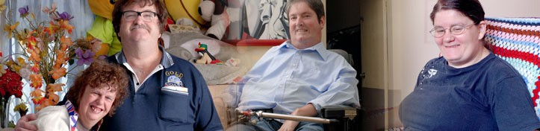

Mission: Empowering the voices of people with disabilities in Western Australia.

Vision: A community where all people have a full and valued life with the freedom to make their own choices.

Values:

- We embrace diversity and participation to ensure inclusion for all
- We believe respect is fundamental to all positive relationships
- We seek to enhance opportunity and remove barriers to ensure real choice
- We are committed to every citizen’s right to equality

PWdWA is funded by the Disability Services Commission and the Department of Families, Housing, Community Services and Indigenous Affairs.

President’s Report
Last year I reported on a year of change and development. Once again, I start by reporting further change. The Executive Director, Louise Durack, stood for the federal seat of Stirling in the recent elections and resigned her position at Easter to pursue this commitment. Members may be aware that PWdWA was fortunate in appointing Mark Goerke to the position of Executive Director. Mark had twenty years experience at Anglicare, and brought a wealth of knowledge and fresh ideas to PWdWA. I am thankful to our Senior
Individual Advocate, Andrew Jefferson, who stepped into the position of Acting Executive Director when Mark took prearranged leave. PWdWA is most fortunate to have a team of highly skilled and dedicated staff.

Leadership changes have not distracted from the organisation or its work with the community.

Senior Systemic Advocate, Kerrie Duff, has promoted the rights of people with disabilities in Western Australia and further afield. Kerrie’s knowledge of the disability sector and relationships with key stakeholders is greatly valued.

Samantha Jenkinson completed valuable research into health issues for women with disabilities. This was compiled into a report that was launched in 2009. The launch was opened by the Honourable Sue Ellery, Shadow Minister for Disability Services. Over 70 people attended and heard about the needs of women with a disability and the unique issues they face. Rayna Lamb, President of Women with Disabilities WA, highlighted some of the more pressing issues faced by women when attending medical appointments, such as the need for better information, accessible consulting rooms, height adjustable beds and improved training for doctors. The launch was very well received by health professionals, disability specialists and people with disabilities alike.

The Productivity Commission Inquiry into Long Term Care and Support has involved a great deal of time in discussions, forums and submissions. The Productivity Commission is exploring a proposal to develop a National Disability Insurance Scheme (NDIS). PWdWA worked with the Western Australian Disability Coalition and the Australian Federation of Disability Organisations to ensure that the needs of people with disabilities in Western Australia were recognised.

Last year I reported how PWdWA was promoting inter-agency co-operation with People With Disabilities Australia (PWDA). I have since been elected as a board member for a term of two years. This has been a great opportunity to exchange ideas where I both learn and contribute. A Memorandum of Understanding is being developed to formalise the relationship between two independent organisations that share similar values and goals.

PWdWA has also had the opportunity to extend its links within WA through

collaboration with the Ethnic Disability Advocacy Council (EDAC) and the Aboriginal Disability Network (ADN). Together we successfully tendered to provide a disability advocacy service in the Kimberley. EDAC is the lead agency and PWdWA has been involved in the provision of induction training for the new advocate.

Members may have had a chance to use our new website. The site was developed by Loaded Studios with important input and co-ordination by Stuart Jenkinson, our Information Advocate. Feedback so far has been that the site is easier to navigate and provides improved information.

As always PWdWA’s individual advocacy remains of high importance and at the core of our work. Carmen Pratt-Hicks and Lisa Hook have worked tirelessly to secure positive outcomes. Keith Read, our Advocate in Peel, now works three days a week following an increase in funding from FaHCSIA. Andrew Jefferson has been instrumental in guiding the individual advocacy team. His role promotes the well-being of both staff and clients.

Disability Services Commission has renewed funding for Disability First Stop (DFS) for the next three years. Advocate Christina Wright will be able to continue her important work with adults who recently acquired a disability. She has achieved great outcomes with many people and is commended for her tremendous passion and commitment.

Stephanie Thompson’s tenure as Officer Manager has assisted the smooth running of our organisation. She has played a key role in the planning for PWdWA’s return to our offices at Oasis Lotteries House in Nedlands, and has helped manage the lengthy delay in this process following the hail storm in March.

The newly renovated offices will have new computers, a new phone system and a phone number and offer a bright friendly meeting room for everyone who uses Oasis House including the Committee of Management. All staff put in a huge effort to accomplish a smooth transition when the office moved to the temporary residence in West Perth and I am confident the same will occur when we return to Nedlands.

The Committee of Management has demonstrated great commitment to PWdWA’s values and strategic objectives. I take this opportunity to thank each person for their work, commitment, and support throughout the year. As always PWdWA has strived to do the very best for its members and to represent the wider community on those issues which impact most on people with disabilities.

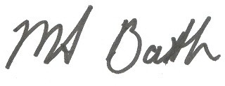
Mary-Anne Bath

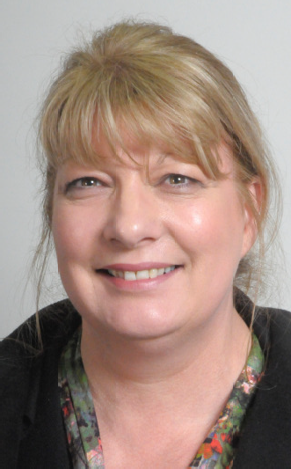Treasurer’s Report

It is with pleasure that I present this year’s Financial Report. The report shows that People with disabilities WA Inc. operated within its approved budget and within the contractual requirements of our core funding bodies Disability Services Commission (DSC) and the Commonwealth Department of Families, Housing, Communities and Indigenous Affairs (FaHCSIA).

As the Income Statement and Balance Sheet demonstrate, the
organisation remains very sound financially. We have finished the year with a total surplus of $37,693. Due to both staff changes and the disruption to the office as a result of the relocation to West Perth during the refurbishment of Oasis Lotteries House, there has been an underspend in DSC and FaHCSIA funding. With approval from both Departments these funds will be carried forward to 2010/2011 and be used for individual advocacy, the funding of a new office in Peel, operating the Developing Active Citizens program and contributing to the cost of paying for the Senior Individual Advocate as intended.

I would like to take this opportunity to acknowledge the invaluable support from Lotterywest who have provided assistance with relocation costs while our offices at Oasis Lotteries House have been undergoing refurbishment, and a further grant to enable the purchase of much needed equipment throughout the office.

On behalf of the Board I would like to express our thanks to Graham Holman, Heather Blythe and the staff at Independent Administration who continue to provide professional accounting services and advice throughout the year.

The Board is not complacent but does believe that PWdWA is well positioned to move forward towards the achievement of its operational and strategic goals whilst retaining the ability to provide a high quality service to families in WA. We remain confident about our future but recognise the need for careful stewardship in these difficult economic times.

Sharon Van der Laan Treasurer

2009 Committee of Management

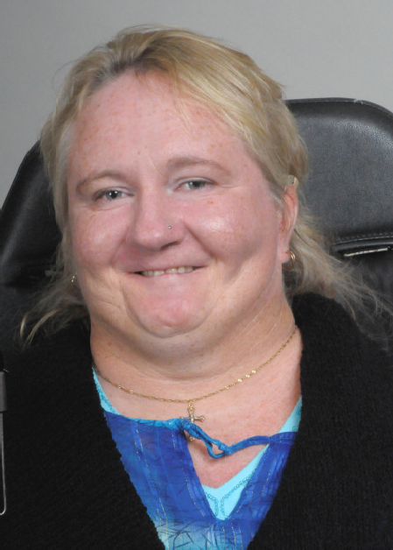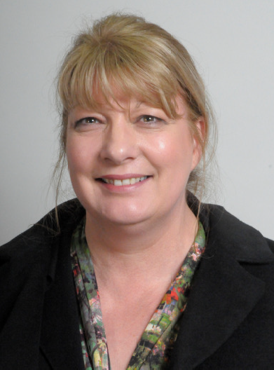

Mary-Anne Bath President

Greg Madson Secretary
Monica McGhie Vice President

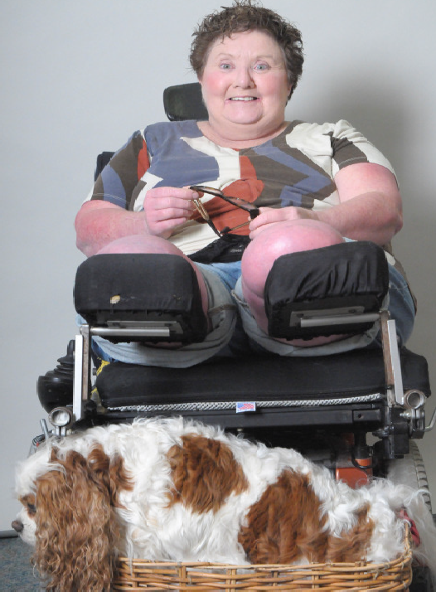Trish Anderson
Sharon Vanderlaan
Treasurer

Samantha Neylon

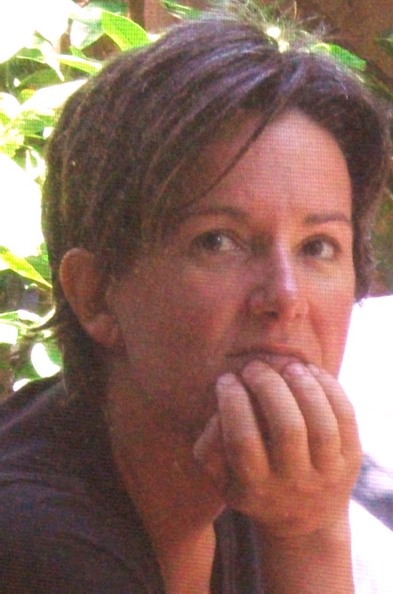
Leah Thomlinson-Clements Karen Soldatic—Co-Opted

Executive Director’s Year

In a year of great change the continuity provided by our President Mary-Anne Bath and members of the Committee of Management served the organisation well. The staff team had to make many adjustments during this period and the ‘can do’ attitude they demonstrated was commendable.

The most significant change experienced was Louise Durack’s departure from her role as Executive Director in March 2010. Louise was a dynamic leader and with the guidance of the Committee of Management she worked tirelessly to promote, develop and enhance the work of our organisation. Louise campaigned strongly for the rights of people with disabilities and encouraged collaborative work between individuals, organisations and stakeholders from across the disability sector. She recognised the need for strong independent advocacy to empower the voices and protect the rights of people with disabilities and she advocated for this on both a local and national level. Louise developed and maintained a dialogue with senior politicians, executive managers and other key decision makers. She ensured that our work was informed by people with a lived experience of disability and, with the support of Senior Systemic Advocate Kerrie Duff, was active in seeking the views of individuals, representative organisations and members.

During 2009/2010 a series of measures were undertaken to enhance the quality of the advocacy services provided by PWdWA. The Executive Director worked alongside the Committee of Management to strengthen the governance and operational management of the organisation. They developed a strategic plan that built upon the values and strengths of the organisation. Our thanks go to Dee Roche for the expert guidance she provided in these processes, and to Blake Dawson staff for their continued support and considered advice.

Louise was succeeded by Mark Goerke in March 2010. Mark had a wealth of experience in the human services sector.

PWdWA relocated to West Perth while its offices in Oasis Lotteries House were being refurbished. The timetable for this was badly affected by the hailstorm in March 2010 and caused considerable disruption for staff and to our plans. We are very grateful for the generous financial support we received from Lotterywest to permit the improvements to our workplace. We particularly appreciate the understanding and helpful approach taken by their staff following the storm.

PWdWA had much to celebrate in the past year. The Individual and Disability First Stop Advocates reported many positive outcomes for the people using our services; there were also many significant steps taken to achieve systemic improvements for people with disabilities on both a local and a national level. PWdWA’s progress was made possible by the continued support and funding of both the Disability Services Commission (DSC), and the Department of Families, Housing, Community Services

and Indigenous Affairs (FaHCSIA). The day to day assistance provided by Mike Roberts from DSC and Leonie Heydon from FaHCSIA is very important to us.

As a result of additional funding provided by the DSC, Andrew Jefferson was appointed Senior Individual Advocate in July 2009. This addition has enabled the Individual Advocacy team to develop both a methodology that better supports the advocates and an approach that encourages consumers to maintain control of their cases.

PWdWA has continued to be an active member of the Disability Coalition in Western Australia and maintained close links with the Australian Federation of Disability Organisations. We have strengthened our relationship with People with Disabilities, Australia and value the assistance that we receive from the Disability Discrimination Unit at Sussex Street Community Law Centre.

In the coming year PWdWA looks forward to enhancing the opportunities and reducing the barriers for people with disabilities in Western Australia.

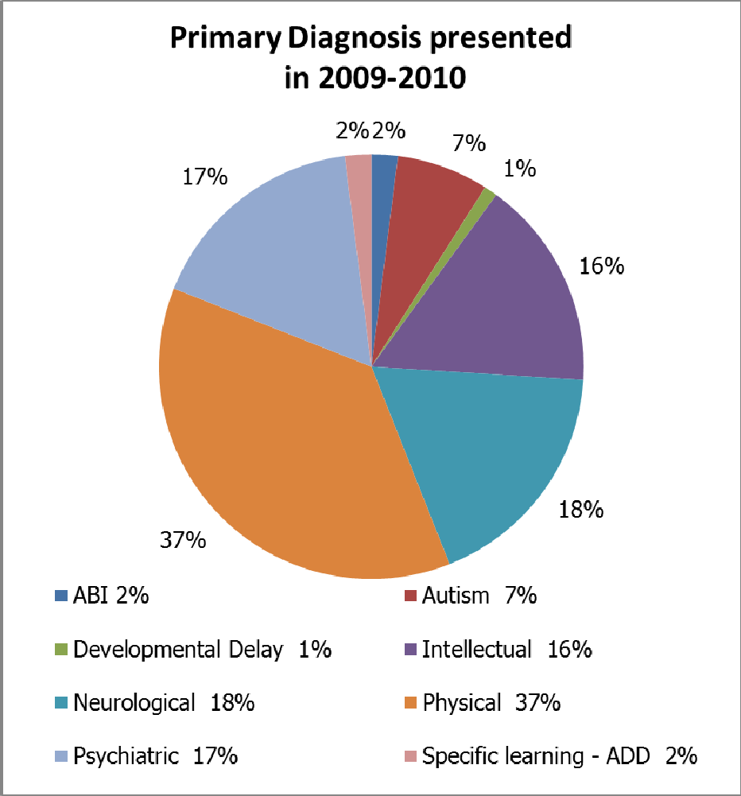
Services

Individual Advocacy

Our services provide people with disabilities the opportunity to be heard. We aim to provide people with factual information, help to consider a range of options and strategies, and if required, direct advocacy support to communicate or action their preferred plan.

PWdWA provided independent advocacy services for people with a lived experience of disability during 2009/2010. We assisted
individuals, couples, family members, carers and supporters. From the feedback we received the advocacy support we provided has been central to many individuals and families achieving positive outcomes for themselves and for others important to them. Some of the people we worked alongside did not go on to achieve all of their goals and while this was a disappointment to them Individual Advocates were thanked for the informed, committed and respectful way they approached their role. Several people took the time to contact PWdWA to convey their appreciation and ensure senior staff understood the difference the Advocate made to their lives. This feedback was very humbling. Our thanks go to those who took the time to share their feelings.

PWdWA’s Individual Advocacy programs are funded by both the Disability Services Commission (DSC), and the Department of Families, Housing, Community Services and Indigenous Affairs (FaHCSIA).

The Advocacy team has benefitted from access to a comprehensive range of training courses, information sessions and advocacy forums this year. Team members consider that this has resulted in each becoming more competent and confident practitioners. Advocates receive professional supervision and peer support in what is a very demanding role.

During 2009-2010 PWdWA was contacted regarding a wide range of issues affecting the quality of people’s lives. Individual Advocates provide non-legal advocacy. As the result of great pressure on the Legal Aid system this year PWdWA advocates have been required to assist many more people with the difficult task of accessing appropriate legal services or assisting with them with mediation processes. We have acted as advocates for individuals with disabilities with issues involving the Family Court, child protection agencies, Magistrate’s Court and the State Administrative Tribunal. We have advocated in situations involving the Office of the Public Trustee; the Equal Opportunities Commission; and the Office of the Public Advocate.

The work of the advocacy team involves assisting people who have a lived experience of disability resulting from variety of conditions. As the year progressed it became evident that we were engaging with a high number of people who identified as having a psychiatric disability. The most pressing of the problems identified were an inability to access acute health and mental health services, and isolation.

Individual Advocates through Accommodation Advocacy have been involved in several cases where consumers were dissatisfied with the accommodation support service they have received. In these situations the issues involved can be very complex and may concern a wide number of stakeholders. These cases are resource intensive and advocacy can be required for several months.

Individual Advocates have assisted several individuals to exercise their right to change Accommodation Service Provider. This is a significant undertaking and requires careful planning. Some of the people who contacted us decided to stay where they were but received advocacy support to challenge the Support Provider about the way that they were being treated. One person was assisted through advocacy support to move on to a more individualised housing and support arrangement. Another person, considered at risk by his parents, moved quickly from one shared living situation to another with a different Support Provider.

Our Individual Advocates have supported people to be heard, built self-advocacy skills and achieved positive outcomes concerning matters such as education, abuse and neglect, finances, housing and access to services.

An Individual Advocate supported a parent of a child with a disability at meetings with the school representatives to successfully obtain an Educational Assistant and to put systems in place to promote an inclusive environment that maximises the child’s learning opportunities.

A woman without speech was supported to voice her concerns. She asked for her rights to be respected by her support provider who was overriding her choices and ignoring her decision making capacity.

Advocates assisted people with disabilities to speak to creditors and prepare documents before making supported referrals to the Financial Counselling service of their choice.

An Individual Advocate advocated for a mother of children with disabilities who was living in a Department of Housing house with substandard conditions. Through this support the family were placed on the priority transfer housing list. Consequently the family moved to a better house. The amenities in the area are better and this has provided a better quality of life for them all.

Feedback from consumers indicates that the assistance of independent advocates has been crucial in helping some individuals escape from abusive situations or to overcome discrimination.

Individual Advocates have enabled many people address issues that were causing distress or have been barriers to them leading an ordinary life.

Andrew Jefferson - Senior Individual Advocate

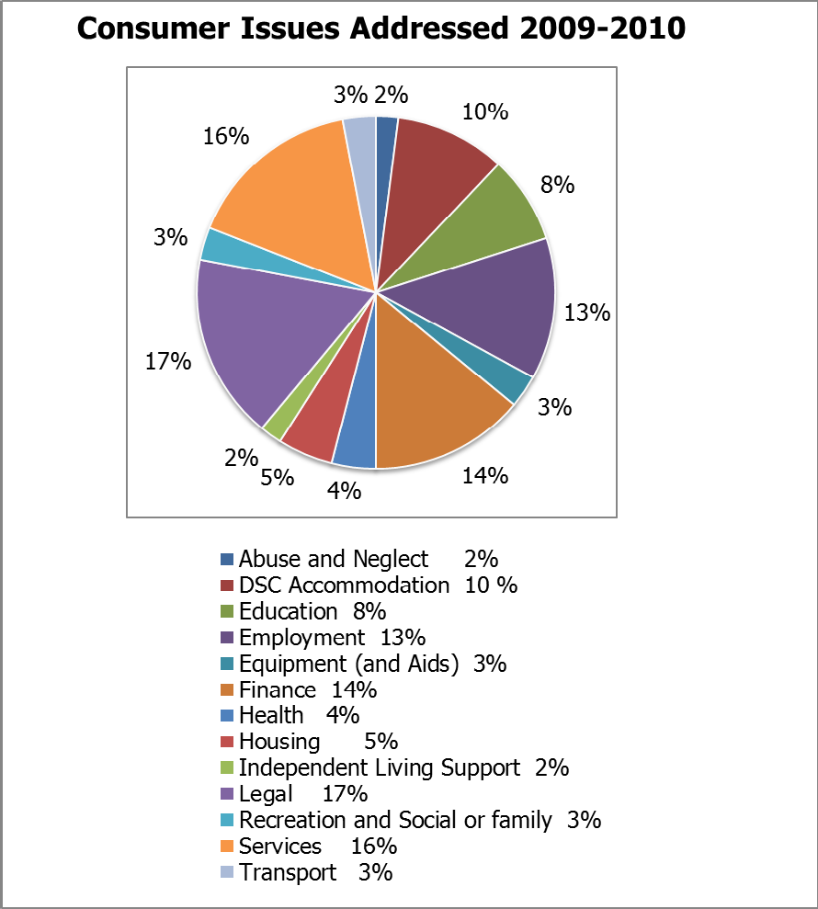
“From the very first phone call – I was made to feel welcome and comfortable. What a friendly lot!! Carmen was very helpful and supportive for the whole of the time that we were trying to get something positive from Management. She understood the problem completely and was very helpful with follow up information and in the ways that we handled any procedures. She travelled to my work place a couple of times to meet with our CEO – and I believe went outside her duties. And finally – we did have a positive result – not only for my self but for all those that would’ve been at that same level. Carmen gave me the support I needed to stick to my guns and see it through!! If I have any problems again – I won’t hesitate to contact PWd.” Dot Webb

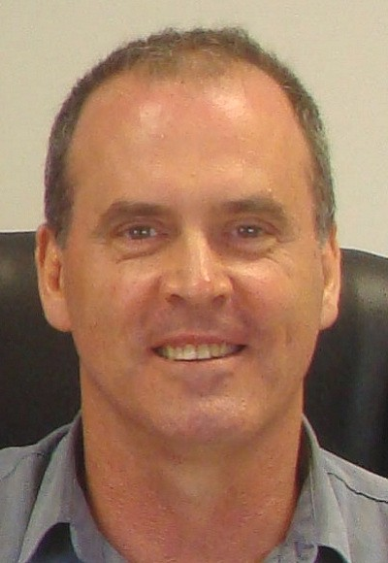Peel Individual Advocate – Annual Report 2009/10

The 2009-2010 year saw the first full year of the Individual Advocacy service in Peel offered for 22.5 hours per week as a result of a funding increase. These additional hours enabled PWdWA to provide a more comprehensive advocacy service for people with a lived experience of disability in the Peel region. This extra capacity has allowed PWdWA to promote the availability of an independent advocacy service across both the disability sector and the wider
community, something identified as being of particular importance in a Regional area.

The advocacy service provided in the Peel Region has continued to grow in quality and scope, with 23 clients being supported through direct advocacy. The Peel Advocate has worked alongside people in a range of activities including, preparing for meetings, consulting with professionals, researching information, assessing risk and assisting people to consider options, and action planning. People who were assisted through individual advocacy resided in the Local Government areas of Mandurah, Waroona, and Murray.

It was noted that an increased percentage of the clients assisted in the Peel Region have identified themselves as having a psychiatric disability. The adequacy of mental health services in this Region has been the subject of public debate for some time. The number of people with a history of psychiatric disability seeking advocacy may be a reflection of unmet need.

With the expansion of the Individual Advocacy service in Peel, it has been important to continue to develop relationships with relevant services and agencies within the region to raise awareness of PWdWA and to promote collaborative working to ensure the best possible outcomes for clients. To this end, the Peel Advocate has regularly attended meetings of the Peel Mental Health Week Committee, Alcohol and Other Drugs Group, and the Peel Network Service Providers Group. He has had meeting with representatives from the Peel Mental Health Service, Personal Helpers and Mentors Programme, various supported accommodation providers, and Local Government Departments.

The search for office space in the Mandurah area continues. Our preferred option fell through at a very late stage. This was very disappointing. Along with our funders, we consider the service will be enhanced by a local office.

From the feedback received it is clear that PWdWA provides an essential service to people with a lived experience of disability in Mandurah and the surrounding area. The Peel Individual Advocacy Service is funded entirely by the Department of Families, Housing, Community Services and Indigenous Affairs and we very much appreciate their continued support to people with disabilities in the Peel Region.
Keith Read—Advocate

Disability First Stop

Disability First Stop provides a responsive person-centred service recognising each person’s unique circumstances in the period following diagnosis.

Disability First Stop is funded by the Disability Service Commission. We are pleased to report that the Commission renewed the funding agreement for this important service for a further three years from 30 June 2010.

The four partner agencies providing a Disability First Stop Service are People With disabilities (WA), Headwest, the Ethnic Disability Advocacy Centre and Kalparrin.

Each agency has responsibility for the provision of a Disability First Stop service to particular demographic groups of individuals. The partner agencies meet quarterly to share ideas and formulate strategies for developing and improving the service.

The Disability First Stop advocate at People With disabilities (WA) Inc provides information, supported referrals and direct advocacy support to adults who have been recently diagnosed with a disability (18-24 months). The advocate works alongside the person with disabilities and their family to help guide them through a period of great change and adjustment. The advocate helps people to navigate the disability services environment and access the support required.

During 2009 – 2010 the people seeking assistance increasingly included people with a pre-existing diagnosis who have acquired a second disability. The challenges that face people with a dual diagnosis are considerable. While one might imagine that people would have access to twice as many services in these circumstances, the opposite can be the case.

Kalparrin, EDAC and PWdWA participated in ’Harmony on Hyde’. This was coordinated through the Town of Vincent to promote awareness of services within the wider community.

Christina Wright Advocate
Disability First Stop

Information Advocacy

Throughout 2009-2010 PWdWA responded to more than 400 telephone and email information enquiries from individuals with disabilities, their families and carers, service providers, and the wider community. The quality of the information provided reflects the knowledge and experience of the advocacy team. The requests for information and advice covered a diverse and extensive range of topics including:

- Education related issues
- Disability based Discrimination
- Employment for people with disabilities and associated services
- Mobility Aids & Equipment as well as funding to acquire them
- Access to Health Services
- Legal Services
- Recreation & Social Activities for people with disabilities

When providing information or directing enquirers to other services and resources care is taken to ensure that advice is relevant and current. This often requires considerable research using our extensive database, the internet and our large network of contacts within the disability sector.

PWdWA produced 4 editions of our newsletter ‘The Advocate’ in the 2009/2010 period. The newsletter is a source of useful information and articles. It details information about PWdWA activities and includes local and national disability news. ‘The Advocate’ is available on the PWdWA website and is distributed to over 300 addresses.

The PWdWA website underwent a comprehensive redesign process following a period of consultation with members and other interested parties. The new site has received lots of positive feedback. It is now more accessible and easier to navigate. Conversations with people with a lived experience of disability will be ongoing to ensure that the website’s content and access continues to improve. The potential for more interactive features will be pursued over the coming months. The use of Facebook and Twitter to enhance communication with members is being actively considered. Our thanks go to Damien Katich, Heath Properjohn and the team at Loaded Studios for the inclusive way they approached the design process.

Since the May launch of the new website, there has been an average of 3500 visitors per month to the site.
While PWdWA embraces the use of technology where possible, we also recognise that not everyone has access to computers or the internet and will continue to endeavour to make information available in alternative formats on request.

Stuart Jenkinson—Information Advocate

Understanding our Rights and Responsibilities… Making our own Choices…
Having a Voice and Being Heard!

During the year, members of SAWA raised a wide range of issues that were affecting their daily lives. These included relationships within their workplace; pay and conditions at work; and housing and accommodation issues. People helped each other to understand the challenges that they were facing. Members considered what actions could be taken to overcome these difficulties. The hailstorm of March 22 was a major event in people’s lives and served as a discussion topic over several meetings. Members of the group also spoke about good experiences such as family activities and milestones reached. Wonderful memories were shared by individuals on return from holidays in many parts of Australia and overseas.

The monthly meetings remain an important forum in which members can confidently share their concerns and experiences with others. Members provide each other with information, perspective, and options. Everyone participates in meetings. Each person’s input is respected and confidence within the group is growing. Members report on how they have spoken up for themselves or gained the assistance of others to address matters causing concern. SAWA have also started to talk about the potential for a national disability insurance scheme. Members are aware that the situation at present is not fair and they want this situation to change. SAWA members believe that each person should have a big say in what goes on in his or her life and that people who provide support should listen more to people with disabilities.

PWdWA benefits immensely from hearing first hand the issues that are affecting people with intellectual disabilities living in the Perth community. We appreciate the open way that the SAWA members communicate and the commitment that each makes to the group.

The SAWA office bearers have served the committee well under the leadership of Karen Evans in the last year. Plans for the forthcoming twelve months include exploring: computers that can convert text to spoken word; ‘smart living’ enabling technology for the home; assistance animals; IT training; and self-advocacy skills sharing. PWdWA staff Bobby Smith, Stuart Jenkinson, Andrew Jefferson & Christina Wright have been pleased to support the members SAWA over the past year.

The elected office bearers for 2009-2010 were:
Chair Person: | Karen Evans | Vice Chair Person: | Joyce Airey
Secretary: | Rita Grose | Vice Secretary: | Ian Grose
Treasurer: | Ian Grose | Vice Treasurer: | Karen Smith
Email Secretary: | Erica Wise | Birthday Person: | Karen Smith

Systemic Advocacy

PWdWA had a very full year addressing the many issues that are barriers to all Western Australians with disabilities achieving equality. There were many important contributions made by individuals and organisations to assist us in our work. I take this opportunity to express my gratitude to the many people who supported our activities and events. My particular thanks go to the people with a lived experience of disability who participated over the course of the year.

While the Productivity Commissions Enquiry into Long Term Care and Support, and the proposed National Disability Insurance Scheme, required a lot of attention this year there were many other issues addressed through systemic advocacy.

More than 20% of the Western Australian community are people with disabilities. Following concern about people finding it difficult to access electorate offices, PWdWA conducted a survey in September 2009. Over 50% of state politicians responded. Of these, 79% reported good physical accessibility to their offices. Respondents indicated a strong willingness to improve access and facilities for constituents with disabilities via hearing loops, provision of accessible toilets, assistance for people with sight impairment via way finding, and other means. Nearly half of the MPs went on to modify their offices following the survey.

PWdWA wrote to the Premier to encourage the Department of Premier and Cabinet to audit all electorate offices with a view to attaining equal access for people with disabilities and their supporters to consult their elected representatives.

On International Women’s Day PWdWA launched ‘Access to Women’s Health Services for Women with Disabilities.’ The report detailed the alarming neglect of this group’s reproductive and sexual health needs by mainstream health services often due to discrimination or ignorance. Women with disabilities see their doctor almost twice as often as the general population. The inability to access a clinic or receive timely treatment is an increased health burden on individual women and leads to more pronounced needs for critical care on the health system when issues remain untreated.

Early in the year we hosted an open forum to address concerns around the State Government’s review of human services. This was the first of several forums that allowed for information sharing and dialogue with stakeholders about matters including the Productivity Commission’s Inquiry into Long Term Care and Support, and the Economic Audit Committee’s Social Reform recommendations. PWdWA members also contributed to the review of the National Disability Service Standards and attended the forum facilitated by the Disability Services Commission.

We were pleased to be involved in the launch of the You’re Welcome WA program and continue to serve on the Disability Services Commission’s Reference Group, and Joint Accessible Tourism Western Australian Reference Group.

The SMS Assist Working group convened by WA Police and hosted by DSC has made considerable progress with input from PWdWA and other key agencies.

PWdWA promoted an online survey for the WA Catastrophically Injured Project facilitated by UWA and ICWA. We thank those members who gave up time to participate in the working groups focussing on this important issue. The final report is due to be released shortly.

In a landmark decision PWdWA provided support during the crucial final segments of a project which saw the Disability Services Commission assist an individual to pilot the first truly individualised funding model. The individual’s family helped set up a ‘sole trader’ business, naming the individual as the proprietor. PWdWA assisted the individual and family clarify what happens to public funds allocated to assist people with disabilities and their carers, so the funds can be efficiently applied in a manner which increases value for money for both the Commission and the individual and which is clearly accountable concerning the quality and costs of service provided.

PWdWA continued to serve on the Housing Advisory Roundtable. We submitted a letter to the Social Housing taskforce through the Western Australian Council of Social Services about people with disabilities needing equitable and appropriate distribution of new housing stock that is cost-effective with related resources.

PWdWA continued dialogue on the issue of dignified and equitable access to air travel collaborating with DSC’s Access and Inclusion Branch and the Ministerial Advisory Committee on Disability to prepare a useful resource for people with disabilities intending to fly.

PWdWA member Raima Flanagan continued to represent PWdWA on the Synergy Customer Advocacy Committee.

Secretary of the Committee of Management, Greg Madson, represented PWdWA in consultations around transport access.

Disability Coalition of Western Australia

PWdWA has benefitted from collaborative working with our Disability Coalition partners: Ethnic Disability Advocacy Council; Disability Development Council; Headwest; Advocacy South West; Carers WA; and the Ministerial Advisory Council on Disability.

The Coalition had a busy calendar of meetings and events. Our campaigns focused on key issues including the Economic Audit Review, the Productivity Commission enquiry, and preparation for the Federal Election. The coalition partners also participated in quarterly meetings with DSC Director General, Ron Chalmers.

Kerrie Duff
Senior Systemic Advocate

Anti Poverty Forum

PWdWA, in partnership with the WA Council of Social Services (WACOSS), held a forum on the 8th of October 2009 leading into Anti Poverty Week. This event was an opportunity to highlight the considerable additional expenses that people with disabilities experience, and the higher likelihood of a person with a disability living in poverty. The invitation for this event was extended to PWdWA members, Members of Parliament and, in particular, their electorate staff. The event at the Boulevard Centre was attended by 30 people.

The first presentation was delivered by Irina Cattalini, Director of Social Policy at WACOSS. Irina defined poverty and analysed the key indicators of social exclusion. Irina highlighted the social demographics that link disability and poverty. For example, 75% of people who do not report a disability are employed while only 50% of people who reported a disability have a job.

Louise Durack, Executive Director, explained both the individual and systemic advocacy services provided by PWdWA. She discussed the strategies used to assist people with disabilities to achieve their goals. She highlighted the principles that underpin PWdWA’s advocacy approach and suggested some information and referral points that may be of use to the forum participants.

Carmen Pratts-Hincks and Lisa Hook from PWdWA provided Individual Advocacy case studies illustrating why people with disabilities are more likely to live in poverty. Their examples demonstrated that a shortage of appropriate affordable housing; limited employment opportunities; inadequate educational options; and financial abuse are some of the wide range of risk factors that lead many people with disabilities to live in poverty.

Monica McGhie, Vice President of PWdWA, shared her personal story with the audience. Monica highlighted some of the additional costs she faces as a person with a disability simply to meet her basic needs. Monica discussed how poverty further reduces the chances of a person with a disability overcoming the many day to day barriers to a successful life.

“The forum has given me better knowledge of what support is available to those with disabilities at all levels and how disabilities affect someone’s socio-economic situation. Thank you for this invaluable information. It helped put issues relating to this in perspective.”

People With Disabilities WA Inc.

Financial Statements for the Year Ended 30 June 2010

PEOPLE WITH DISABIUTIES (WA) INC

FINANCIAL STATEMENTS FOR THE YEAR ENDED

30 JUNE 2010

  - Auditor's Report

  - Statement by President

  - Income Statemeot

  - Balance Sheet

  - Statement of Cashflows

  - Notes to and forming part of the accounts Notes 1 - 10

PIUNC' IPAT :
RAY WOOLLEY PTY LTD
ACCOUN TANTS

1 9 B AY PORT C l RCU IT

RJ\Y WOO L L EY I· C •\ ( UI. I. c 111,,,,,1
PIIO E: (Ofl, 94 0 8 5155
FAX: (08) 9408 5166
\-t l NDAR TE WA 6(130

PO BOX 2011

l:.MA IL: n1yw, (
iincl.m:t.a u
CLARKSON WA 603{1

PEOPLE WITH DISABILITIES (WA) INC

INDEPENDENT AUDIT REPORT TO THE MEMBERS OF PEOPLE WITH mSABIUTIES (WA) INC

Scope

The financial report and commi tt e e's responsibility.

The financial report comprises the balance sheet, income statement, cash flow statement, accompanying notes to the financial statements and the statement of the comm ittee for People With Disabilities (WA) Inc for the year ended 30 June 2010.

The committee are responsible for the preparation and the true and fair presentation of the financial report and have determined that the accounting policres used and described in Note 1 to the financial statements which form part of the financial report are consistent with the financia l reporting requirements of the Association s Incorporat ions Act {WA) and are appropriate to meet l he nee<is of the membe rs. This includes responsibility for the mainte nance of adequate accounting reco rds and intern al contro11 s that are desig.ned to prevent and detect fraud and error, and for the accounting policies and acco unting estimates inherent in the financia l report

The fina ncial report has been prepared for distribution to members for the purpose of fulfilling the committees ' financial reporting requirements under the Assoc iations In co r porations Act (WA}. We disclaim any assumption of responsibility for any reliance on this report or on the financial report to which ii. relates to any person other than the members, or for any purpose other than that for w'hich it was prepared.

Audit Approach

We conduded an independent audi,t in order to express an opinion to 1he members of the orga nisation. Our audit was conducted in accordance with Austra lian Auditing Sta ndards, in order to provide reaso nable assuranoe whether the financial report is free of material misstatement. The nature of an audit is influenced by factors such as the use of professional judgement, selective testing, the inherent limitations of internal control, and lhe availability of persuasive rather than conclus ive ev idence. There fore, an audit cannot guarantee that all material misstatements have been detected.

We performed procedures to assess whether in all m aterial respe cts the financial report presents fairly, in accordance with the Associations Incorporat ions Act (WA), includin g compliance with Accounting Standards and other mandatory financial reporting requirements in Australia, a view which is consistent with our understanding of the organisatio n's financial position, and of its performance as represen ted by the results of its operations and cash flows.

RAY WOOLLEY PTY LTD
A

PRJ ( I PAL:
RAY\ 00 I l I I II , , . )
PHO E: (0 ' ) 9 4 08 5 155
FA. ·: (OX)940 1 (,6
F·. 1A II · r-t)W a i1m:1.111:1.a u
19 R ·\ ' PO RT ( JR< lJ IT
Ml DARI \ 60 0
PO RO. 20 1 7
LARK. 'O \\ 6fl30

PEOPLE WITH DISABILITIES (WA) INC

INDEPENDENT AUDIT REPORT TO THE MEMBERS OF PEOPLE WITH DISABILITIES (WA) INC
continued

We formed our audit opinion on the basis of these procedures, which included .

examining, on a test basis, information to provide evidence supporting the amounts and disclosures in the financial report, and
assessing the appropriateness of the accounting policies and disclosures used and the reasonableness of the significant accounting estimates made by the commi ttee.

While we considered the effectiveness of the management's internal controls over financial reporting when determining the nature and extent of our procedures, our audit was not designed to provide assurance on interna l contro ls.

Independence

In conducting our audit, we followed applicable independence requirements of Australian professional ethical pronouncemen s

Audit Opinion

In our opinion, the financial report of People With Disabilities (WA) Inc presents a true and fair view in accordance with the accounting policies described in Note 1 to the financial statements, of the financial position of People With Disabilities (WA) Inc as at 30 June 2010 and the results of ,ts operations and its cash flows for the year then ended.

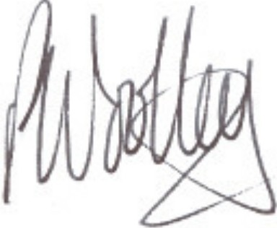
Ray Woolley Pty Ltd Ray Woolley
Registered Auditor No 16396 24 August 2010

19 Bayport Circuit Mindarie
WA 6030

PEOPLE WITH DISA,B LIT IES (WA) iNC

STATEMENT BY PRESIDENT

for the year ended 30 June 201o

T he B oa r d of Man agement declare that:

- The attached finand al statemen ts and no tes th ereto comply with accounting standa rds

- The attached financial statemen ts and no tes thereto give a true and fair view of th e financial position and performance of the associa tion ; and

c} In the Boan:! of Manag ement's opinion , there are reaso nable, gr ounds to believe th at the Association will be able to pay its debts as and when they become due and payab le.

Signed on be half of th e Board of Managemen t

Mary-Anne Bath President

PERTH , WA

PEOPLE WITH DISABILITIES {WAl INC
Balance Sheet a at 30 June 2010

 | Note | 2010  $ | 2009  $
Current Assets
Cash at Bank and on Hand | 3 | 297,813 | 306,772
GST - Input Tax credits |  | 8,466 | 3 577
Debtors and Prepayments |  | 3,346 | 2,095
Total Current Assets |  | 309,625 312,444
Non-current Assets
Plan Equipment and Vehicles | 2 | 26,066 27,024
Total Non-current Assets |  | 26,066 27,024

Total Assets 335,691 339,468

Current Liabili ties  Sundry Creditors and Accrued Expenses | 4 | 12,687 | 37,711
Income Received in Advance | 5 | 81,875 | 96,337
GST - collected |  | 18,630 | 17,345
Prov,s,ons -Annual Leave & Sic Leave | 6 | 28,71 | 36,530
- Long Service Leave | 6 | 0,063
- Refurbishment |  | 21,580 | 21,580
Total current liabiliti es 173,546 209,503
Non Current Liabilities
Provisions - Long Service Leave | 6 | 28, 23 | 33,636

Total Non Current liabilities 28, 23 33,636

Total Liabilities 201,669 243,139

Net Assets | 34,022 | 96,329
Accumulated funds | 3 ,0:l2 | ,329

PEOPLE WITH DISABILITIES (WA} INC

Income Statement
for the financi al year ended 30 June 2010

Revenue from Ordinary Activities
Not s 2010
$
2009

Grants

- Disability Services Commission
-FAHCSIA

344,971 304,613
206,981 1 9,659

Interes t Donations
embership lotterywest 0th r Gr nts
Profit on Sale of Assets Sundry Income

Total R venue from Ordin ry Activities Expenses from Ordin ry Activities
Accounting nd Audit fees Advertising and recruitment
AG and General eetmg costs Depreciation
Equtpment Expenses
Insurances - General & Motor Vehicle
I.T. Expenses ewsletter
Postage
Printing nd Stationery Rent
Repairs and Maintenance Salary and wages costs Subscriptions Telephones
Transport Costs Workshops/consu ltants Utilities
-
Other Expenses

Total Expenses from Ordinary Activities Operat ing surplus/(defic it)
Non-Operating Revenue Total surplus/(deficit)
8,942 9,541
640
2,301 1,177
76,213 6,600
26,546
630 2,415
33,030 2,746

673,708 553,297

5,073 4,663
6,464 9,700
6,665 9,155
9,609 9,771
31,008 4972
8,0 8 6,106
15,229 5,216
83 1,122
1,403 1,774
16,802 13, 06
60,108 10,829
4,963 23,088
431,827 382,928
701 609
12,715 9,742
10,857 6,064
31,798
4,221
9,466 8,265
636,015
539 408

37,693 13,889

7

37,693 13,889

I nf lows (Outflows)
$ $
Inflows (Outflows)

Cash flows from operating ac ivities

Grant Income | 676 ,522 | 584,723
Interest Received | 8,941 | 9,541
Membership and Donations | 2,941 | 1,177
Other Income | 33,029 | 9 ,346
Payments to Suppliers and Employees | (722,371) | (480,506)

Net cash provided by/{used in) operating activities Cash flows from investing activities
(938) 124,281

Non-operating Income  Proceeds from sale of property, plant and equipment | 8,636 |  | 15,000
Payment for property, plant and equipment | (16,657) |  | {17,058)
Net cash provided by/(used in) or from investing activities |  | (8,021) |  | (2,058)
et increase in cash held |  | (8,959) |  | '122 ,22 3
Cash at beginning of the financial year |  | 306,772 |  | 184,5 49
Cash at the end of the financial year |  | 297,813 |  | 306 ,77 2

STATEMENT OF CASH FLOWS

(a) Rec oncil iati on of Cash

Fort e purposes o the statemen of cash lows cash includes cas on hand and in banks and inves men s m money ma e instrumen s, ne o outstandin g ba nk overdrafts . Cash at the end of t e financial year as shown in the s a ement o cash ows s reconci led to e rela ed items in the balance sheet as follows·

010

Cash Depo,s

s a Call

180,994
1 6 819

245,485
61.287

297,813 306,772
- Financing F cilitios

o Fac1l1ti es are m place as at 30 June 2009

- Rec onc i liati on of not cash providod by operating 2010 2009
activitios to operating sur plu s.

Operating surplus((deficit) 37,693 3,889

Profi on disposal of non-current asse s (630) (2 415)
Depreciat on and amortisation of non-current assets 9,609 9,771 Non operating income
Changes in net assets and liabilities Decrease in current receivabl es
Increase in current receivables (6,139) (914)
lncrea e in curren creditors (23,739) 36,583
Decrease m curren t creditors
Increase in current provisions (3,270) 13,650
Decrease in current provisions
Increase m income in advance (14,462) 53,717
Decrease in income in advance

e Cash provided by/(used in) operating acti vities (938} 24 281

PEOPLE WITH DISABILITIES (WA) INC

Notes to and forming part of the accounts for the year ended 30 June 2010

1 Summary of Accounting Policies

The principal accounting policies of the Association, which are set out below, have been consistenUy followed in all material aspects.

- The accoun ts are prepared m accordance with the historical cost convention.

- The provision for long service leave is calculated at current rates of pay for all staff
from their date of commencement. Long service leave entiUement is due after 7 years service for the first and subsequent terms.

The Associa tion's Performance Agreement with the Disability Services Commission now requires it to make provision for Long Service Leave as per its employee entiltlement policy.

{b) Holiday pay is accrued based upon holiday entitlement and pro-rata at current rates of pay plus 17.5% loadings, Superannuation and Workers Compensation liabilities for applicable staff.

- Provision for Sick Leave has been accrued on the basis of 50% of the outstand in g balance as at 30 June 2009, plus superannuation and workers compensation liabilities for applicable staff.

- Depreciation is calculated on a straight line basis so as to write of the net cost of each fixed asset during its expected life. The depreciation r ates used are:

Plant and Equipment | 20%
Furniture & Fittings | 20%
Motor Vehicles | 20%
Computers | 33%
Buildings | 2.5%

Since June 2000 it has been the policy of the Association to not capitalise items less than
$5,000 in value. These amounts are written off wholly in the year of purchase. The Association is not funded for capital replacement within it's current grant structure and does not have the capacity to put aside cash reserves to cover these expenses. Component parts will be grouped together to determine the value to be used in determ ining the $5,000 limit.

PEOPLE WITH DISABI ITIES (WA) Inc
for the year ended 30 June 2010

  - Plant/Equipment nd Vehicle s

Gross Carrying Amount Plant/equip Veh1c1 s To tal

Balance as at 30 June 2009 Additions
Disposals
Balance as at 30 June 2010

Accumulated Deprec iat i on

Bal nee as at 30 Jun 2009 Disposals
Depreciation Expense
Bal nee as t 30 June 2010

Net Book Value
60,9 0

60,9 0

{57,579)

(3 | .03 )
(60 | ,615)
31,8 0
16,658
(14,804)
33,714

(8,218}
,7 8
(6 573)
(7,993)
92,820
16, 58
( 14,80 )
94,674

(65,797)
6  (9 | ,798  ,609)
8 | , 08)

(

As t 30 June 2009

As t 30 Jun 2010
3,381 23 2 32,322

345 25,721 26,066

2010 2009

  - Cash at b nk and on hand
Cash on hand
Cash al ban - Ban west General Account Gold C sh Man ement Acco unt
Bank west - Term Deposits

300
9,613
131,081
116,819

300
127 368
117 817
61 287

297,813 30 ,772

  - Sundry Creditors Creditors general Accrued expenses

5, 7
7,240

35,03
2,676

12 687 37 710

  - Income Receiv d in Advance

FAHCSIA
D1sab1llty S rv,c s Comm1ss 10n Lo tterywest
Redress COFA
24,708
38,471
14,09

4,600

83,650

8,087
4,600

81,875 96,337

  - Current Provisions
Employ e En itlemen s:
Long Service Leave - short term Long Service Leave - long term

10,063
28 123

0
33 636

38,186 33.636
4 | ,858
36 | .530

Annual Leave Sick Le v
23081
5, 30
28 711
31 672

PEOPLE WITH DISABILITIES (WA) Inc

Notes to and forming part of the accounts for the year ended 30 June 2010

2010
$
2009

  - Non Operating Income

Nil this year

  - Related Party Disclosure

The members of the Committee of Management during the 2009/2010 year ere:

Ms Mary-Anne Bath (President)
Ms Monica McGhie {Vice President) s Sharon Van der Laan (Trea urer)
Ms Carmel1ne Elliot (Secretary) - until October 2009 s Trish Anderson
Mrs Aa1ma Flanagan (co-opted) until September 2009 Mr Greg Madson Secretary from January 2010
Ms Leah Tomlinson-Clemens Ms Samantha Neylon
s Karen Solda ic (co-opted from arch 2010)

  - Superannuation

The Association sponsors the following su erannuation plan for employe s, the details of which are set out belo

Funds Vary based on personal choice .

Type of Benefits

Contributions by :
C
. Employee

    - E mployer
Accumulation of contnbutrons of employee and employer. Covering all employees earning in excess of $450 per calendar month and providing benefits on retirement death or permanent disability.

ii to Unlimited based on personal choice

% based on Government Leg1slat1on .
T he Association has a legal obligation to contribu te as set out in the Superannuation guarantee legislation, but has the right to vary the rate of, or terminate, contnbut1ons upon givrng notice as
prescrib ed in the deed, subject to superannuation guarantee conditions.

Each fund is self administered by the Superannuation Company

