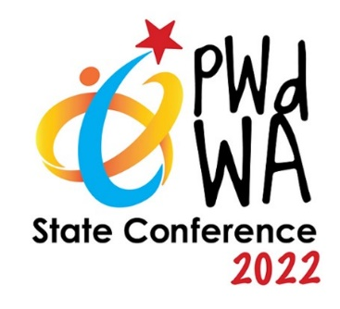
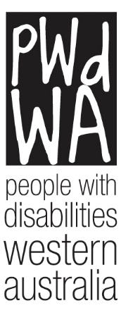

PWdWA

Newsletter

August 2022
- Message from PWdWA
- Current Issues
- PWdWA Profile
- PWdWA in Action
- Upcoming

Message from PWdWA

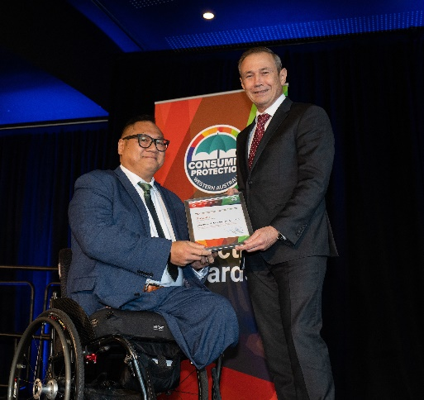
Western Australian Consumer Protection Awards 2022
On Tuesday 2 August, PWdWA was recognised for their work in advancing consumer advocacy in Western Australia by the Consumer Protection division of the Department of Mines, Industry Regulation and Safety.
Nominated for the Richard (Dick) Fletcher Award, which acknowledges a significant and enduring contribution to advancing consumer protection. PWdWA was honoured to be selected as one of the four finalists.
PWdWA would like to extend their congratulations to Financial Toolbox Women at Risk Trust, which supports women at risk of family and domestic violence and/or financial abuse for their well-deserved win.
The image above shows: PWdWA Chair Tom Monks being presented with a finalist certificate by Hon. Roger Cook MLA, Minister for Commerce.

Current Issues

PWdWA State Conference 2022 – Inclusive Communities

Wednesday 7 December and Thursday 8 December

Bendat Centre, Wembley
Have you registered for our State Conference yet? Early bird registrations close on 15 September and PWdWA Full members can get a discount on their tickets. Register Now! | PWdWAConference 2022

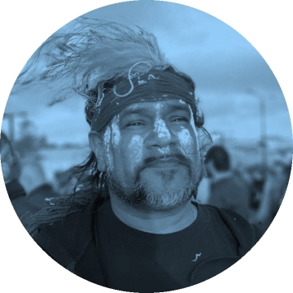
​Welcome to Country
Uncle Vaughan McGuire will be delivering the Welcome to Country on our first day before our Conference begins.
The youngest of seven children, Mr McGuire was born in Balladong Country and is a dedicated Whadjuk man having stories and songs passed down by his father, Whadjuk Elder Walter McGuire.
Mr McGuire is passionate about sharing the knowledge and history of his people and delivers the culture of his great, great, great grandparents with his heart.
Image of Vaughan McGuire from Remix Summits website

PWdWA & Disability Royal Commission (DRC)Community Engagement Event
The Community Engagement Team from the DRC is coming to WA for 3 weeks in August.

PWdWA is collaborating with the Disability Royal Commission to offer an opportunity for a group of people to meet staff from the DRC in West Perth on Monday 22 August to Share your vision for an inclusive future. Spaces are limited to twenty people with a disability.

If you are interested go to Share your ideas for an inclusive future, West Perth, Mon 22nd Aug 2022, 1:00 pm - 4:00 pm AWST | Humanitix. It will take you to the registration page and provide more details about the event.

If you are unable to make this event you can still share your story, for more information go to Share your story | Royal Commission into Violence, Abuse, Neglect and Exploitation of People with Disability.

​PWdWA Profile

Conference Reference Committee
Our Conference Reference Group are busy behind the scenes, ensuring our upcoming conference is a memorable one. In line with our belief that the voices and needs of people with disability should be at the core of everything, every member of the reference group is a person with disability. We would like you to meet the team:
Simon Chong is a former board member of PWdWA, Simon was on our Conference Reference Group for our inaugural State Conference and delivered a report as one of our “keynote listeners” in 2020. Simon is legally blind.
Rachel-Anne Sambell is a Consumer Representative for her local Consumer and Carer Advisory Group and teaches the piano. One of our newer PWdWA members Rachel-Anne enjoys gardening and bushwalking. Rachel-Anne lived experience with a psycho-social disability.
Jamin Dix is one of our Conference Reference Group members for our 2020 State Conference, Jamin has lived experience with Autism and ADHD.
Kat John is a PWdWA board member, an autistic activist, and an advocate with a passion for employment, education and justice. As a member of the LGBT community, Kat brings intersectional experience to our committee.
Nihal Iscel, current Vice Chair of the PWdWA board, Nihal brings 20 years of multicultural and disability experience to the committee. Nihal works at the Ethnic Community Council or WA as the Speak My Language (disability) coordinator for WA.
Amber Jones is a youth consultant with PWdWA’s Economic Participation Project as well as an Occupational Therapy Assistant with an NDIS service provider. This is Amber's first time on a committee and was the first involvement she had with PWdWA. Amber is passionate about nature, animals, marginalised representation and politics. Amber has lived experience of chronic illness and neurodiversity and is a wheelchair user.

PWdWA in Action

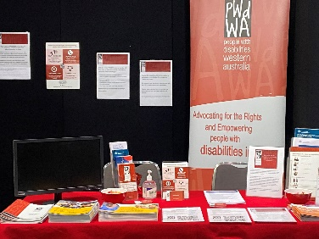
Perth Disability Connection Expo
PWdWA will be at the Perth Convention and Exhibition Centre on 12 & 13 August as part of the Perth Disability Connection Expo.
You will find information on all our upcoming events and Vanessa can assist you in registering for upcoming information sessions, workshops, and the conference.
Entry to the expo is free, if you are there why not stop by stand 51 and say hi to Vanessa?

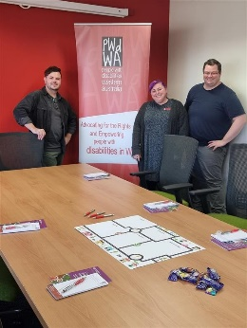
PWdWA Rural Roadshow
PWdWA is bringing its roadshow to Narrogin, Katanning, Wagin, Denmark and Kojonup in August and September.
While registration is not essential, it is preferred. You can register on our Eventbrite page https://www.eventbrite.com.au/o/pwdwa-people-with-disabilities-wa-events-30818099104
Our DRC advocates will be engaging with the community to discuss the challenges that communities have faced, what has brought them together, what is important in your community and what changes would you like to see. They will also provide people with information on how each community member can tell their own story with the Royal Commission.

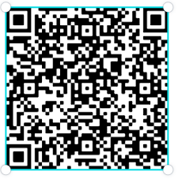
Upcoming

PWdWA’s Eventbrite Home Page
Do you want to know what events PWdWA has coming up? Hold your phone camera over the QR code, then click on the link. This will take you to our Eventbrite home page.

PWdWA’s NDIS Reviews and Appeals Online Information Session 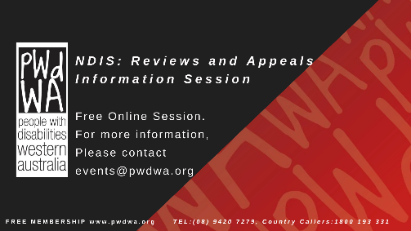

Monday 22 August 2022, 1:00 pm – 3:00 pm
- Do you want to know more about NDIS reviews and appeals?
- Do you want to understand when and how you can ask the NDIS to change their decisions?
We have produced this information session in response to requests from our membership.
This session is for Western Australians living with disability, their families, friends and carers assisting them.
You can register for this event through PWdWA's NDIS Reviews and Appeals Online Information Session August Registration, Mon 22/08/2022 at 1:00 pm | Eventbrite or contact Vanessa on 9420 7279 ext. 717 or email vanessa@pwdwa.org.
If you cannot make our August session, our September session is also open for registration. You can register through PWdWA's NDIS Reviews and Appeals Online Information Session September Registration, Mon 19/09/2022 at 1:00 pm | Eventbrite

PWdWA’s Disability Support Pension Online Information Session
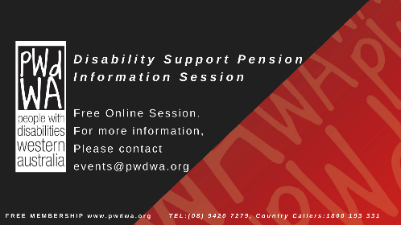

Wednesday 7 September 2022, 10:00 am – 12:00 pm
This session will benefit people about how to apply for the Disability Support Pension (DSP). It will help you prepare and submit a robust application for the DSP by understanding:
- If you are eligible to apply.
- The Centrelink DSP process.
- What information does Centrelink need to assess in your application?
- What is good medical evidence, and how to get it from your health professionals?
- Things you need to know about the program of Support, Job Capacity Assessment and Disability Medical Assessment.
At the end of the session, you will have a good idea of how Centrelink will assess your application. We will also provide tools and links to additional resources to help you.
You can register for this event through PWdWA's Disability Support Pension Online Information Session September Registration, Wed 07/09/2022 at 10:00 am | Eventbrite or call Vanessa on 9420 7279 ext. 717 or email vanessa@pwdwa.org.
PWdWA
PWdWA is funded by the Western Australian Department of Communities and the Australian Department of Social Services.

PWdWA is run BY and FOR people with disabilities and aims to be the voice for all people with disabilities in Western Australia.
Free Membership
Being a member of PWdWA gives you the opportunity to be involved in shaping our organisation through our planning and evaluation processes. As a member, you can make sure the issues that matter to you are heard by being involved with our submissions and advocacy campaigns. Voting is restricted to full members aged 15 years and above.
Full Membership is available to persons living in Western Australia, with a disability, over 15 years who are Australian citizens or permanent residents of Australia.

