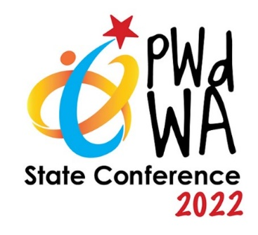
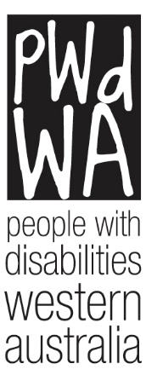

PWdWA

Newsletter

October 2022
- Message from PWdWA
- Current Issues
- PWdWA Memoriam
- PWdWA in Action
- Upcoming

Message from PWdWA

PWdWA Welcomes Appointments to NDIA Board
PWdWA welcomes and is excited by the recent appointment of Kurt Fearnley AO as the new chair of the National Disability Insurance Agency (NDIA), the body responsible for administering the National Disability Insurance Scheme (NDIS). In addition to Mr Fearnley’s appointment, PWdWA also welcomes the appointments of former disability discrimination commissioner Dr Graeme Innes AM and longtime disability advocate and administrator Ms Maryanne Diamond AO as directors, meaning there are now five people with disability on the NDIA board. Mr Fernley said that it was important for people who use the NDIS to see people with a disability involved in running the program.
PWdWA has always held the view that our organisation must be run BY and FOR people with disabilities. While it is encouraging to see that in its history, the recent appointments mean that the NDIA has the largest number of people with a disability on its board, this should be, as Mr Fearnley noted, the “start line and not the end of the journey”.
At the upcoming PWdWA Annual General Meeting, three new board members will be elected from our membership, ensuring that the views of people with disabilities continue to drive and guide the strategic direction of our organisation.

Annual General Meeting
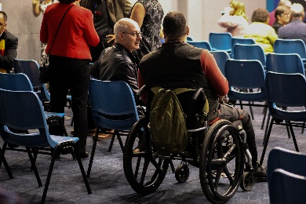
PWdWA’s Annual General Meeting (AGM) will be held at 5:30 pm on 26 October 2022. This year you will be able to attend our AGM in person in the Conference Room at City West Lotteries House, 2 Dehli Street West Perth or online via ZOOM. Auslan, live captioning and captioning on ZOOM will be in use.
We will be serving light refreshments after the meeting.
If you require a screen-readable version of the Annual Report before the meeting, please contact Vanessa at 9420 7279 or email vanessa@pwdwa.org.
You can register to attend the AGM in person, or you can register to attend the AGM online.

Current Issues

PWdWA Individual Advocacy
Due to the high demand for advocacy and limitations in our current staff structure, PWdWA has had to put our waitlist on hold at the moment while we work to increase our capacity.

In the meantime, you can find information and resources on a range of topics, including Making a Discrimination Complaint, NDIS Support and Appeals and the Disability Support Pension, on our website under “how can we help you?”

Our free information sessions on self-advocacy, NDIS Support and Appeals and Disability Support Pension applications are still running, and you can find more information on our Eventbrite page.

Welcome to the team
PWdWA would like to extend a warm welcome to two new members of the PWdWA team. Sandie joins us as an Individual Advocate, and Shzan joins us as a Systemic Advocate while Brianna is on Maternity leave.

PWdWA would also like to welcome Brianna and Joe’s little boy, Charlie, who arrived in early October.

Western Australia's Plan for Plastics
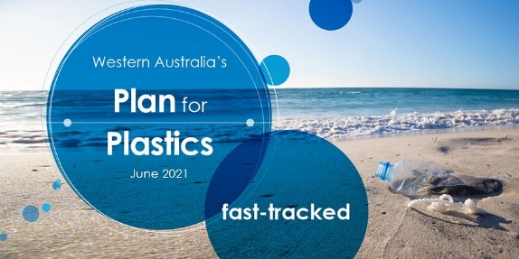
The State Government is taking action to reduce the impacts of disposable plastics on our environment, waste streams and health.
The Department of Water and Environmental Regulation invites you to attend one of their information and feedback sessions on the implementation of stage two of Western Australia's Plan for Plastics. These are being held during October and November 2022.
Eight online workshops will be held, five during business hours and three in the evening.
Day | Date | Time (AWST)
Thursday | 13 October 2022 | 6.30 pm - 8 pm
Wednesday | 19 October 2022 | 10.30 am - 12 pm
Wednesday | 19 October 2022 | 1.30 pm -3 pm
Tuesday | 25 October 2022 | 6.30 pm - 8 pm
Wednesday | 9 November 2022 | 10.30 am - 12 pm
Wednesday | 9 November 2022 | 6.30 pm - 8 pm
Thursday | 17 November 2022 | 1.30 pm -‎ 3 pm

The workshops will provide information on the items proposed to be banned, implementation actions and timeframes for delivery. The sessions will allow you to share your views on what needs to be in place for the change and identify the support you require to adapt to the phase-out of stage 2 items listed in the Plan.
Please register via the link below if you want to attend one of the information sessions. Attendance numbers for each session are limited, so please register early: Western Australia's Plan for Plastics (wufoo.com)
The Government invites you to read the consultation paper Western Australia’s Plan for Plastics Stage 2 (www.wa.gov.au) and encourages you to complete the online survey to receive your feedback on stage 2 implementation.

​PWdWA In Memoriam
Janine Neu – Board Member
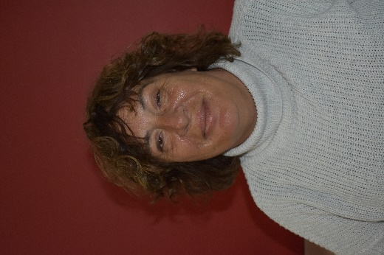
It is with deep sorrow that PWdWA informs you of the passing of Janine Neu. A member since 2016, Janine joined our board in 2017, serving as Treasurer before taking on the role of Deputy Chair in 2018 until 2021. Janine continued to serve as a general member since 2021.
Janine was passionate about maximising opportunities for people with disabilities and supporting individual and systemic advocacy. Janine joined the board of the Australian Federation of Disability Organisations (AFDO) as Deputy Chair in October 2018. She served as a committee member of ACROD and Companion Card External Appeals in WA and was a member of Physical Disability Australia since 2020.
PWdWA extends our sincere condolences to Janine’s partner Bernard, family and friends.

PWdWA in Action

PWdWA State Conference 2022 – Inclusive Communities
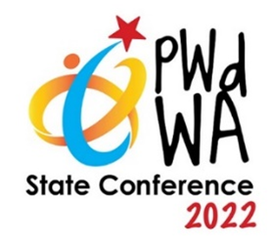
Extension of Early Bird deadline.
PWdWA has decided to extend the Early Bird registration deadline until 14 October.
Join us on 7 and 8 December as we celebrate “Inclusive Communities” with stories of co-design and information on technology that assists with accessibility and inclusiveness. Join discussions with our panels on Legal Issues, Inclusiveness in Sport and the Disability Royal Commission.
A draft of our program is now available online.

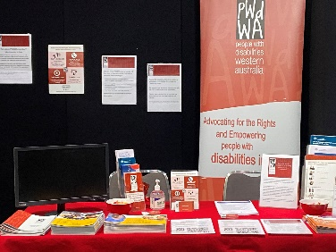

JTCESC Disability Expo
PWdWA will be at the Mandurah Forum on 4 November 2022 for the John Tonkin College Education Support Center Disability Expo.
You will find information on all our upcoming events, and Vanessa can assist you in registering for upcoming information sessions, workshops, and the Conference.

Upcoming

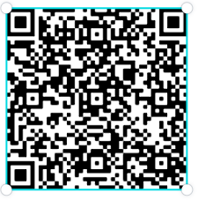

PWdWA’s Eventbrite Home Page
Do you want to know what events PWdWA has coming up? Hold your phone camera over the QR code, then click on the link. This will take you to our Eventbrite home page.

PWdWA’s Disability Support Pension Online Information Session

Wednesday, 23 November 2022, 10:00 am – 12:00 pm
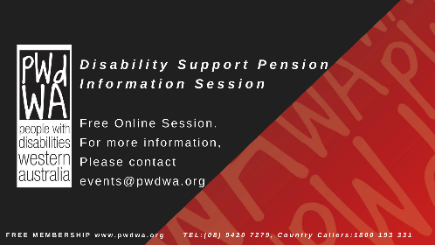
This session will inform people about how to apply for the Disability Support Pension (DSP). It will help you prepare and submit a robust application for the DSP by understanding the following:
- If you are eligible to apply.
- The Centrelink DSP process.
- What information does Centrelink need to assess in your application?
- What is good medical evidence, and how to get it from your health professionals?
- Things you need to know about the program of Support, Job Capacity Assessment and Disability Medical Assessment.
At the end of the session, you will have a good idea of how Centrelink will assess your application. We will also provide tools and links to additional resources to help you.
You can register for this event through Eventbrite or call Vanessa at 9420 7279 ext. 717 or email vanessa@pwdwa.org.

Monday 12 December 2022, 10:00 am – 12:00 pm
If you cannot attend the November session but would still like to find out about the DSP, our December session is open for registration also. You can register for this session through Eventbrite or call Vanessa at 9420 7279 ext. 717 or email vanessa@pwdwa.org.

PWdWA Your Rights, Your Voice Your Choice Face-to-Face Workshop

Friday, 25 November, and Monday, 28 November, 10:00 am – 3:00 pm
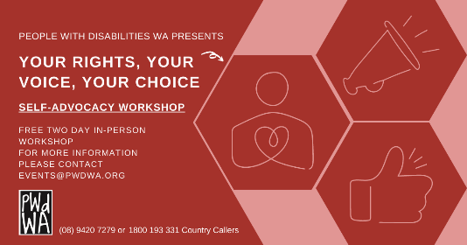
Our free Self-Advocacy face-to-face workshop will be held over two days.
This workshop will introduce attendees to Self-Advocacy and build the necessary self-advocacy skills. This workshop is a two-day commitment, and a certificate will be awarded upon completion.
• Understand your rights and the different types of advocacy
• Learn the key steps to becoming a successful self-advocate
• Explore ways to communicate and how to be more assertive
• Share real experiences and learn from others
You can register for this event through Eventbrite or call Vanessa at 9420 7279 ext. 717 or email vanessa@pwdwa.org.
PWdWA
PWdWA is funded by the Western Australian Department of Communities and the Australian Department of Social Services.
PWdWA is run BY and FOR people with disabilities and aims to be the voice for all people with disabilities in Western Australia.

