On Board with Me Project
People With disabilities WA
November 2018

Introduction
PWdWA has an Information, Linkages and Capacity Building (ILC) 2018-2019 grant to help improve the numbers and opportunities for PWD to be active and valued Board members.
PWdWA are now seeking expressions of interest from interested parties to engage in the project. We are seeking interest from:
- Potential Candidates People with disability who are interested in being a potential candidate for a Board position, and individuals interested in mentoring candidates
- Leadership & Governance Organisations facilitate candidate development and connect candidates to opportunities
- Boards and Organisations who are interested in improving Board Diversity
Project Scope

Planned Grant Outcomes
- Boards commit to include disability in their diversity plans and targets
- Organisations gaining greater understanding of disability
- People with disability with capacity to be on boards
Target Audience
- People with disability interested on working on Boards
- Community and Disability Sector Boards
Timeframe
- Project completion date is June 2019

Roles of Participants and Engagement Opportunities
Project Participating Groups and Stakeholders

The following participants and stakeholder groups have identified for this Project:
- People with Disabilities Western Australia (PWdWA)
- Candidates and Mentors who are people with a disability
- Leadership and Governance Organisations – Including those who provide governance training and recruitment services for Boards
- Participating Boards and Organisations – Organisations in the community services and disability support sector
- Government Boards – Public Sector Commission on associated government organisations that are involved in Government Board recruitment

The Role and Potential Involvement of the Identified Participants

- PWdWA – What will we be doing to improve Board diversity?
- Project management
- Assess sector Board recruitment standards
  - Survey and follow up to assess change
- Board opportunity register
- Candidate nomination register
- Guidelines
  - Development pipeline framework
  - Policy template

- Candidates & Mentors – How you can get involved?
- Project reference group
  - 5 – 7 members
  - Journey mapping onboarding experience
  - Co-Design survey tool
- Candidate or Mentor nomination
  - Diverse Leaders
  - Membership Expression of interest
  - Registration
- Training nomination

- Leadership & Governance Orgs – How can you be a support partner?
- Project advisors
- Board competency framework/ requirements
- Identify mentors
- Training program
- Networking event
- Coaching

- Boards & Organisations – How can you help make the change?
- Complete online survey on Board recruitment processes and practices
- Commit to Policy change, amendment plans and set targets
- Sponsor candidate training sponsorship/ support
- Board pipeline registration
- Board placement
- Government – How can you be a support partner?
- OnBoard WA integration
  - Share Learnings
  - Government targets
  - PWdWA links included in OnBoardWA – Diverse Boards webpage
- Government Board recruitment process

Getting on to a Board - What are the Opportunities Out There?

If you are seeking a Board role, you need to be realistic about what opportunities exist, and the workload required.

Types of Boards and Committees
- The types and structures of Boards and Committees is varied, and can range in size and complexity. From low to high complexity, some examples include:
  - School Parents and Citizens (P&C) Associations
  - Community stakeholder committees
  - Committees of Management or Incorporated Association Boards
  - Board or Local Community Advisory Committees
  - Not for Profit Boards
  - Government Boards
  - Listed Company Boards
- There is very large demand for people wanting to be appointed to Board positions, so it is highly competitive
- There is a current appetite for increased Board diversity which provides the Project with a good opportunity
- Even given the large number of Boards that exist, there are very few that are paid positions. While few Board roles provide good remuneration, other may pay a sitting fee per meeting, or cover incidental expenses

Figure 2: Types of Boards and Committees
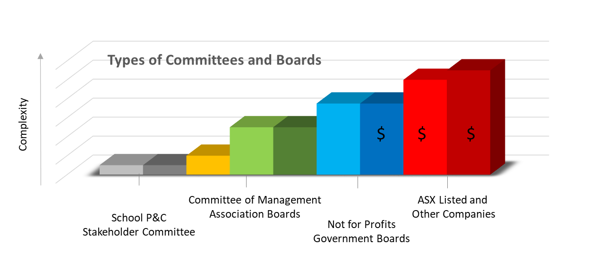
IMAGE
Generic Graph showing the Types of Committees and Boards plotted against increasing complexity.

Effective Governance Board Competency Framework
Figure 3: Effective Governance Board Competency Framework
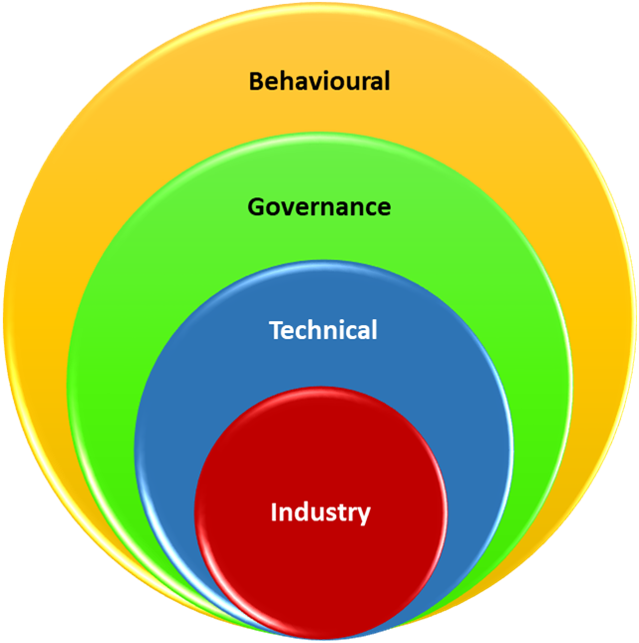
IMAGE
Increasingly sized circles that represent the core and more boarder competencies. From Industry, Technical, Governance and out to Behavioural. Importantly, the Governance and Behavioural Competencies are the largest and most commonly required.
Image Source: GC Kiel et al., 2012 Directors at work: a practical guide for boards, Sydney: Thomson Reuters

- Behavioural
The attributes and competencies enabling individual Board Members to use their knowledge and skills to function well as Team Members and to interact with key stakeholders

- Governance
The essential governance knowledge and understanding all Board Members should possess or develop if they are to be an effective Board Member

- Technical
Technical, professional skills and specialist knowledge to assist with ongoing aspects of the Board’s role

- Industry
Experience in and knowledge of the industry in which the organisation operates
Board Director – Core Competencies
Must have Competencies
- Governance
- Strategy and Risk
- Finance
Good to Have Competencies
- Law
- Accounting
- Strategy Implementation
- Industry Knowledge/ Experience
- Previous Board/ Committee Experience
Bonus to Have Competencies/ Experience
- Lived experience
- Auditing and assurance
- Leadership experience
- Major project experience

It is important that the Must Have Competencies can be demonstrated, and this is best achieved through success completion of formal training.

Development Pipeline and Plan
The project aims to develop a “Development Pipeline” or program for developing Board candidates that is sustainable and will continue to grow over time. The pipeline will begin by identifying suitable Board Candidates.
Selection process and timeline
December 2018
- Interested candidates nominate to be part of the project and are included on the PWdWA Candidate Register
- Interested community service organisations nominate to be part of the project and are included on the PWdWA Organisation Register
Feb – March 2018
- Committed Candidates identified for development program
- Board include topic in Board discussion, consider sponsor opportunities at a briefing or in strategy session

Expressions of Interest
Want to learn more or get involved?
Nominate yourself or your organisation to:

Tracy Destree
On Board with Me Project
PWdWA
1/37 Hampton Road, Nedlands WA 6009
Tracy.Destree@pwdwa.org
0429 564 905

