United Nations Conference of State Parties 16 on the Convention on the Rights of Persons with Disability.
Danielle Loizou-Lake
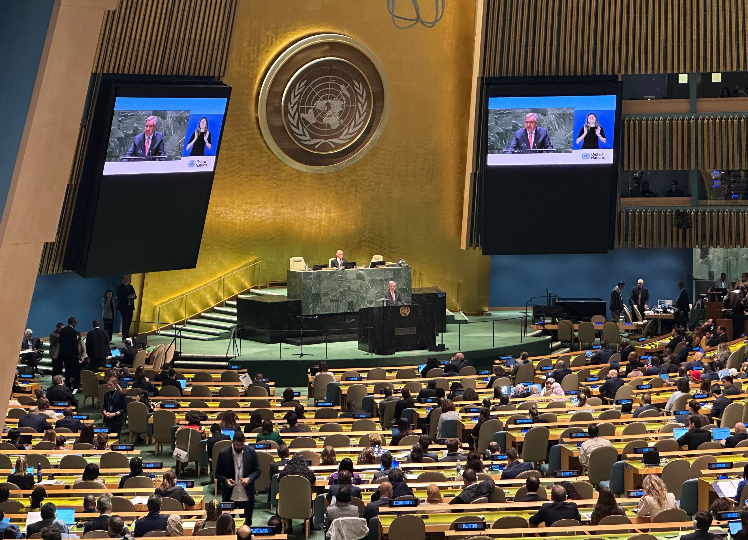
The opening assembly of COSP16

What is COSP, and why is it important?
In July this year, I represented People With disabilities WA (PWdWA) and Western Australia(WA) at the United Nations Conference of State Parties, meeting number 16 (COSP16) on the Convention on the Rights of Persons with Disability (CRPD).

For people living with disability, the Convention on the Rights of Persons with Disability is our international human rights treaty. Australia agreed to be part of this in 2008. It marks an international effort to shift attitudes and approaches from people with disability as ‘objects’ of charity, medical treatment, and social protection, and rather ‘subjects’ with rights, who are capable of claiming those rights and making decisions affecting their own lives.

For me, as a committed advocate, attending COSP16 was an incredible opportunity to participate, advocate and learn more about how WA and Australia are progressing. What I learned; we have so much work to do! We are not as far advanced in inclusion as I thought. Education, health and housing for people living with disability in WA is behind where we should be.

The CRPD and Western Australia
Right now in WA, we have some big changes happening that will set the foundations for the future of disability rights in our state. For example, the Department of Communities, Office of Disability is reviewing the 30-year-old Disability Services Act. In WA, we are a long way from achieving the principles of the CRPD, and reviewing this act to align with the CRPD is essential if we are to make better progress in the future. To be able to do this, we need to have an active state government that works closely with the disability community, local governments and other state services like education and health. This must happen if we are to make our services and communities more inclusive and accessible.

Measuring progress on the CRPD
A big discussion at COSP16 was around how we measure progress. Currently, in WA, we have the State Disability Strategy. There is some general high-level reporting around this. While I was at COSP16, the WA Disability Minister announced WA would report into the National Disability Data Asset (NDDA). This should go a long way in having clear, measurable data about how WA is progressing on the principles of the CRPD. We must keep an eye on this and ensure it measures what is important to us, and that WA is contributing data to the NDDA.
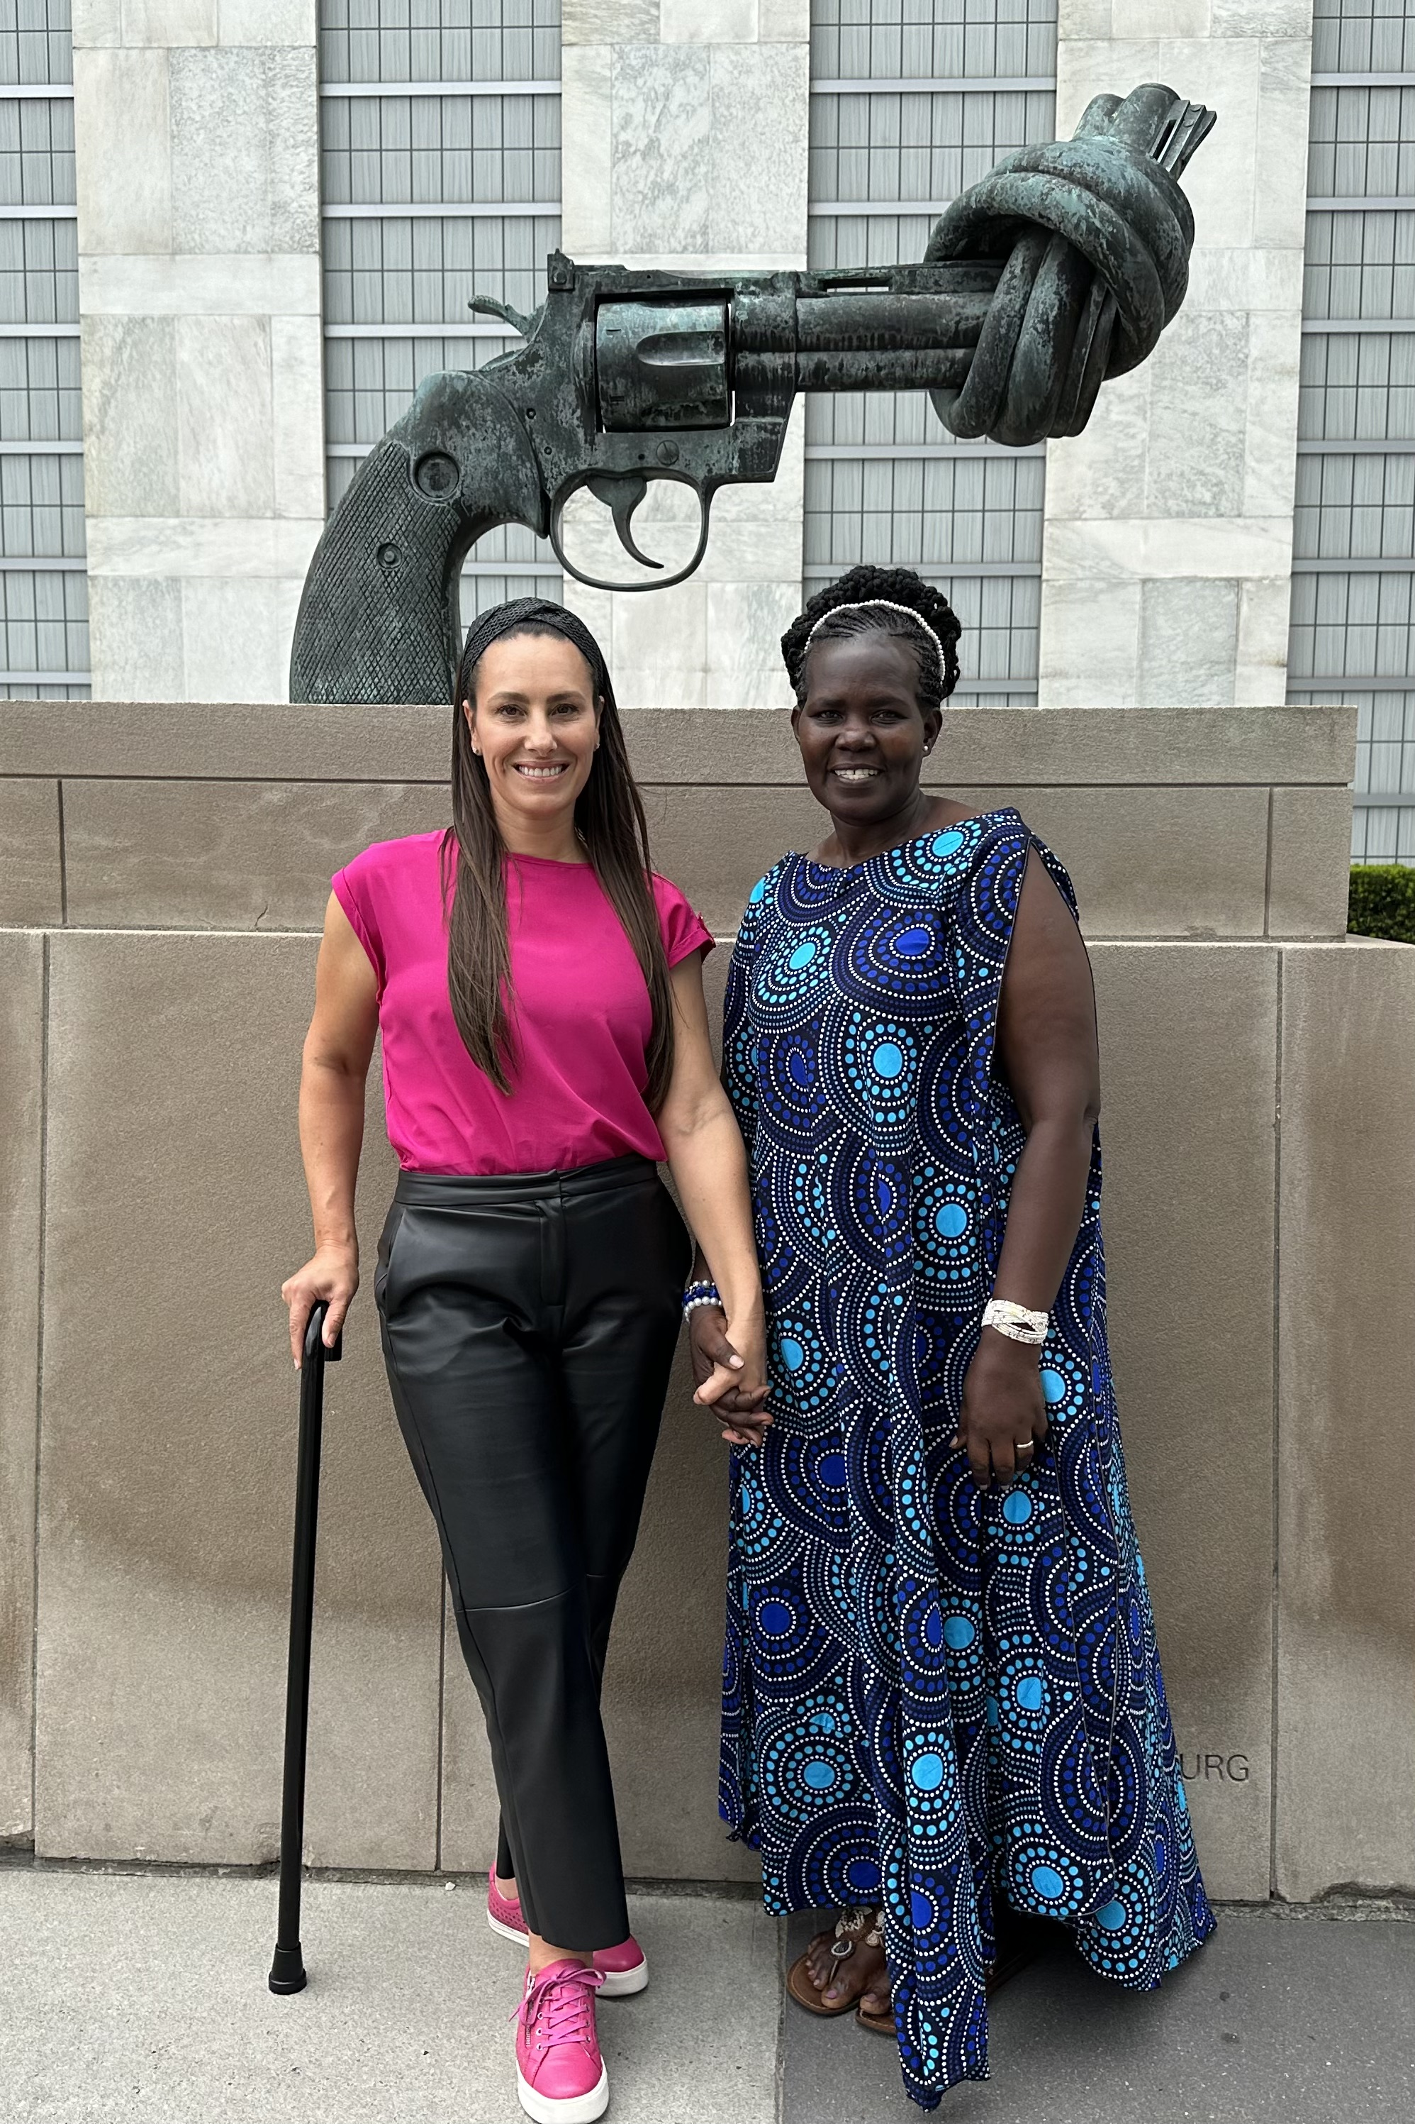
Danielle from PWdWA and Robina from Rwanda both Civil Society delegates at COSP 16

Genuine Engagement
The catch cry at COSP 16 was ‘Nothing about us, without us.’ It was recognised across the world that to achieve the principles of the CRPD, people living with different disabilities must be involved at all stages. It was accepted that it is not appropriate to assume what is best for people when restructuring legislation or services, and that direct involvement of people and communities is required under CRPD.

Reflecting on COSP
Attending COSP16 was an incredible opportunity to share international examples of how we are all working towards this. Some highlights were Ireland's mental health system reform, how collecting data is used to keep governments focused on what’s important and the critical role of us advocates.

Over the week, I attended a lot of side events and supported other Australian advocacy organisations to participate at COSP. These included Down Syndrome Australia (DSA), Children and Young People with Disability Australia (CYDA), People with Disability Australia (PWDA), First Peoples Disability Network (FPDN) and the Australian Federation of Disability Organisations (AFDO).

It’s been 15 years since Australia joined the CRPD, and I learned at COSP16 that Australia has made modest progress. As Western Australians with disability we must expect more. Our State Disability Strategy is aligned with the CRPD, yet progress is slow, and reporting is basic.

If we are to make genuine progress toward the CRPD, we must motivate our state government to make active progress on inclusive education, disability-aware health services and safe, accessible social housing. We must push for Disability Access and Inclusion Plans (DAIP’s) to be more robust and accountable, so our communities across the state actively work toward becoming more inclusive and accessible.

The CRPD guiding principles are:
- Respect for dignity and individual autonomy
- Non-discrimination
- Full and effective participation and inclusion
- Respect for difference and acceptance of persons with disabilities as part of human diversity
- Equality of opportunity
- Accessibility
- Gender equality
- Respect for the evolving capacities of children with disabilities

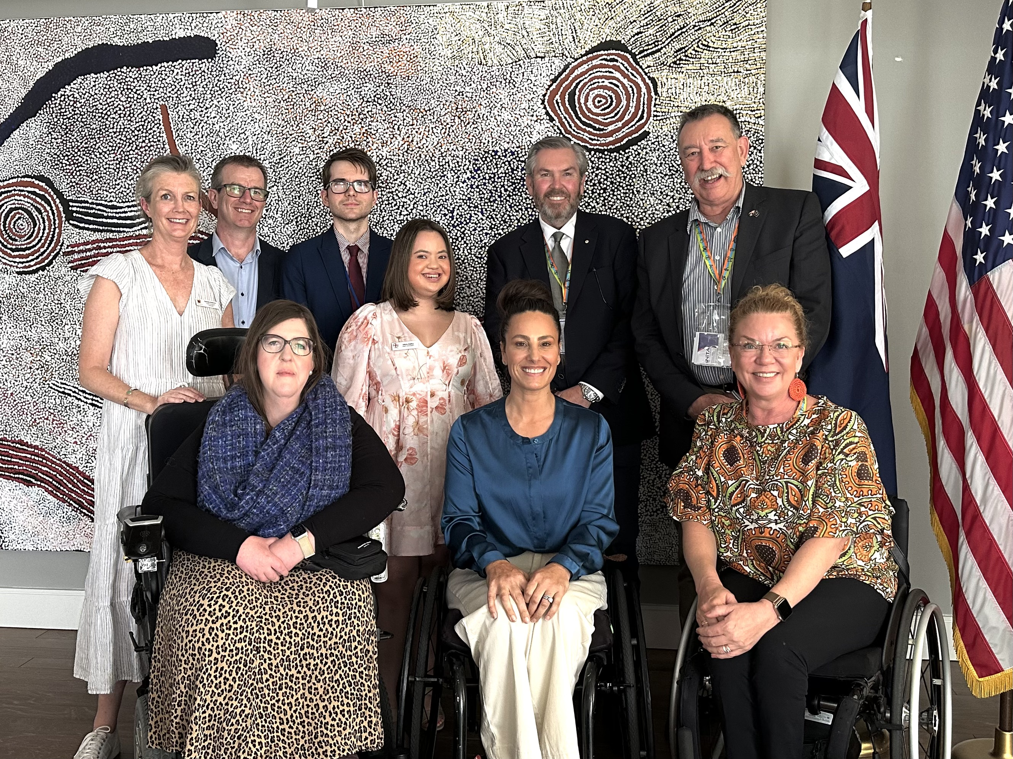

Danielle (PWdWA) and members from the Australian Federation of Disability Organisations (AFDO), Down Syndrome Australia (DSA) and Children and Young People with Disability Australia (CYDA) at a side event hosted by SSA and attended by Minister Amanda Rishworth.

